**SBA-7 (JMeter)**

The Apache JMeter application is open-source software, It is a Java application designed to load test functional behavior and measure performance.

**Steps** :

Step 1: Download JMeter

Step 2: Start JMeter batch file in bin folder

To run the JMeter as a batch file from bin directory.

Create a test plan for our web application’s load testing

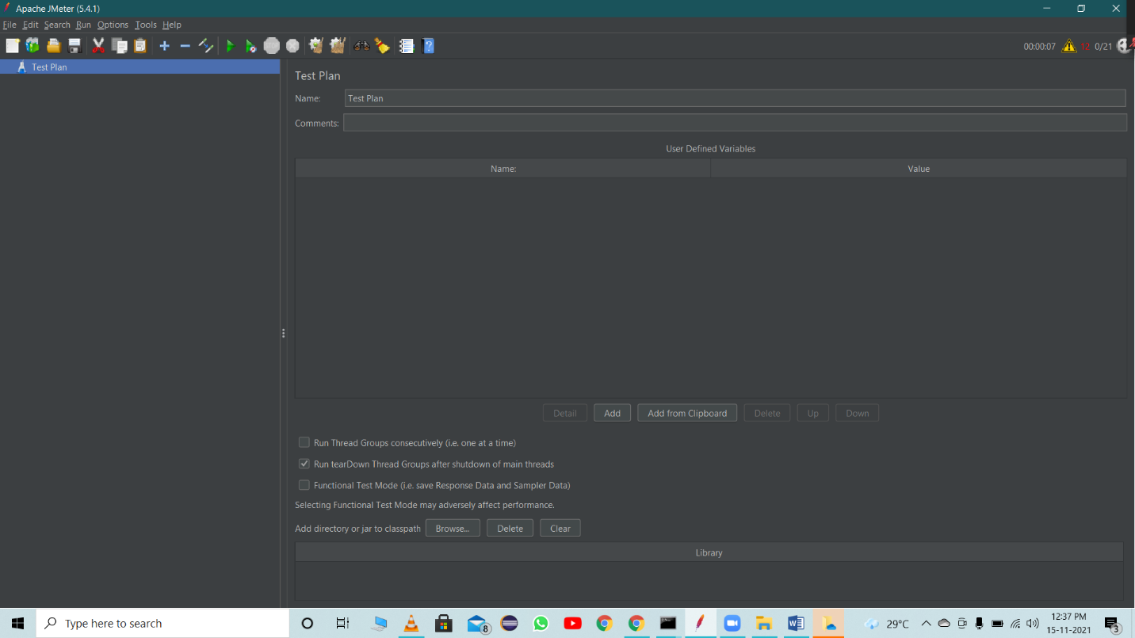

**Create Thread Group**

To create a thread group.

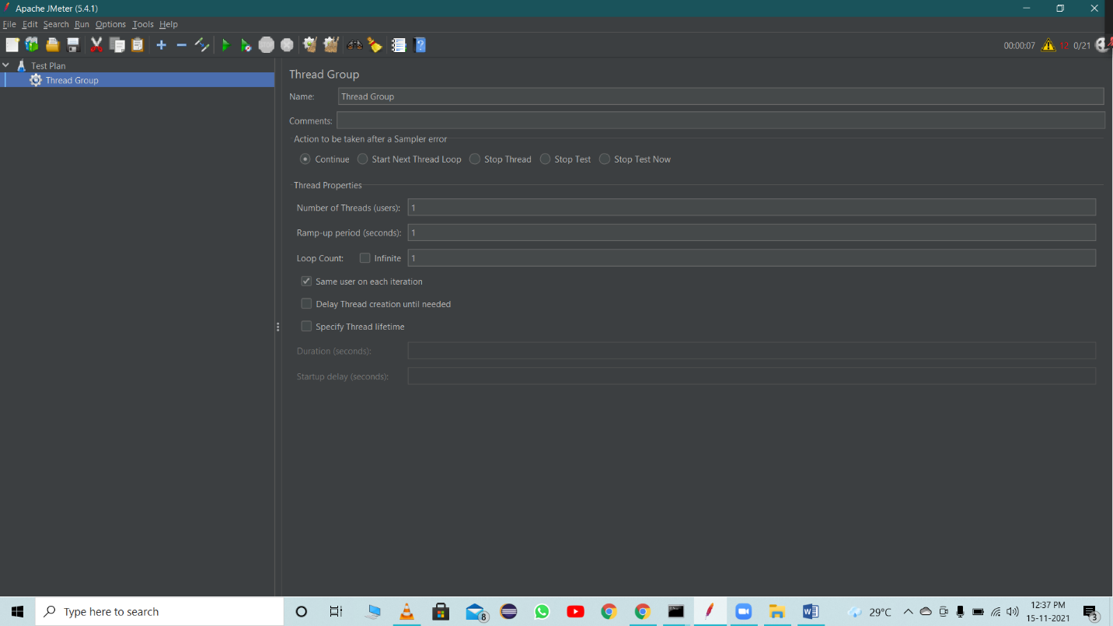

**Right Click on thread group and create a sampler (HTTP Request)**

To add HTTP request details

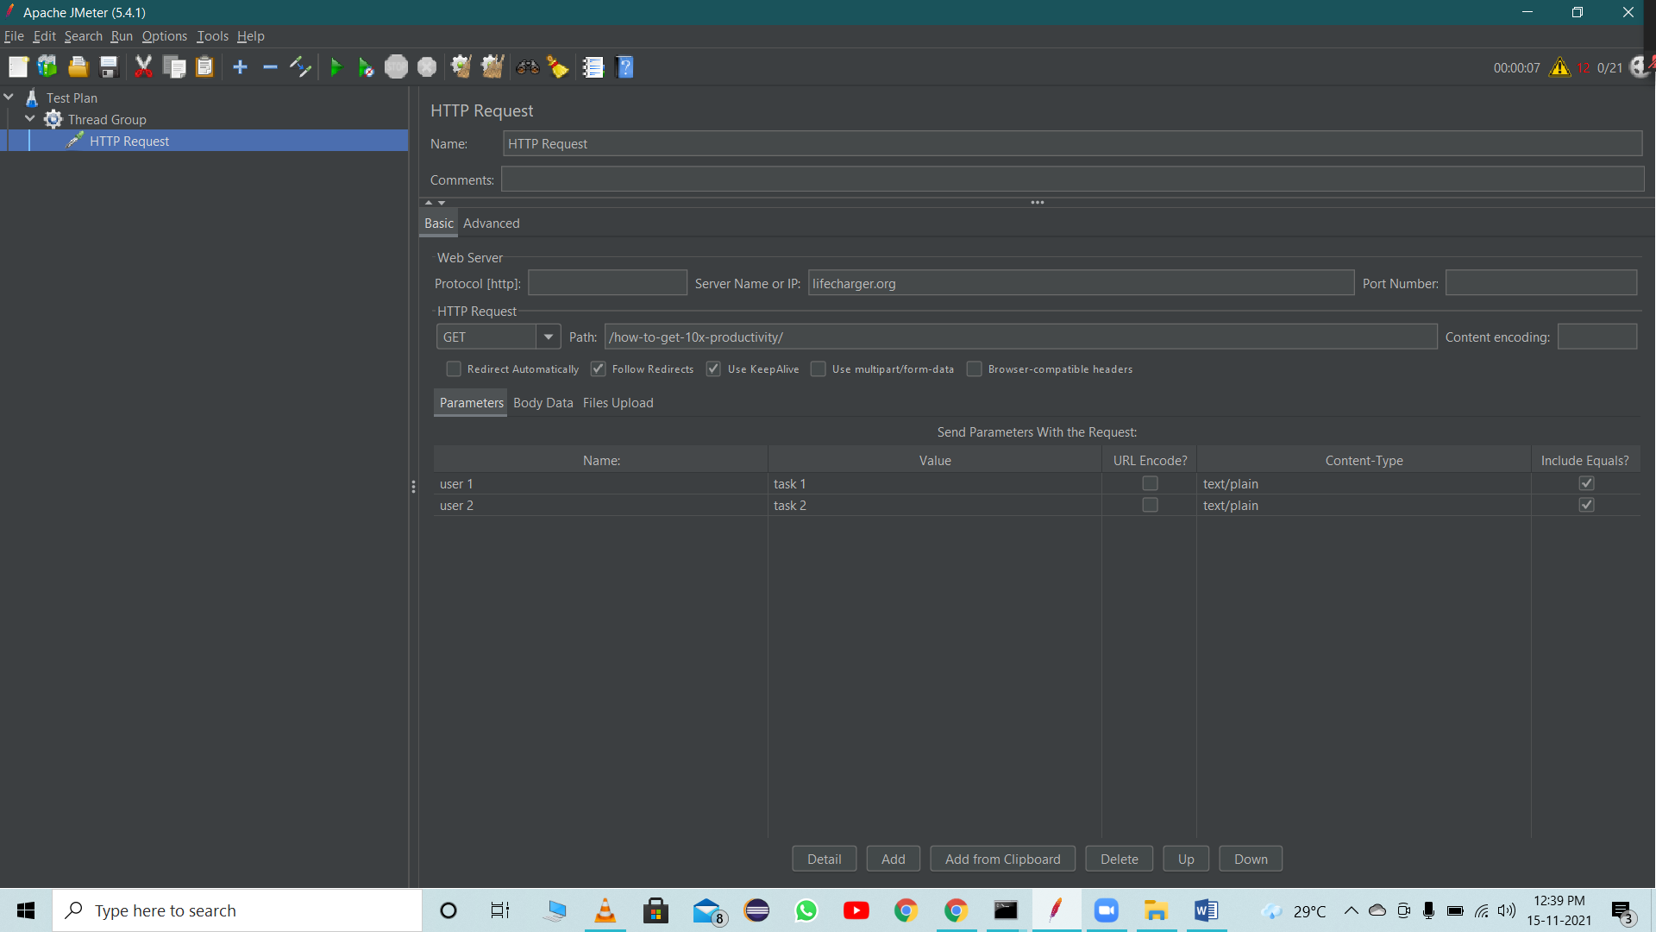

**Add Listener**

Listener helps us to see the output data. We have various types listeners available like tree, table and aggregate report etc.

We used View results tree for this example

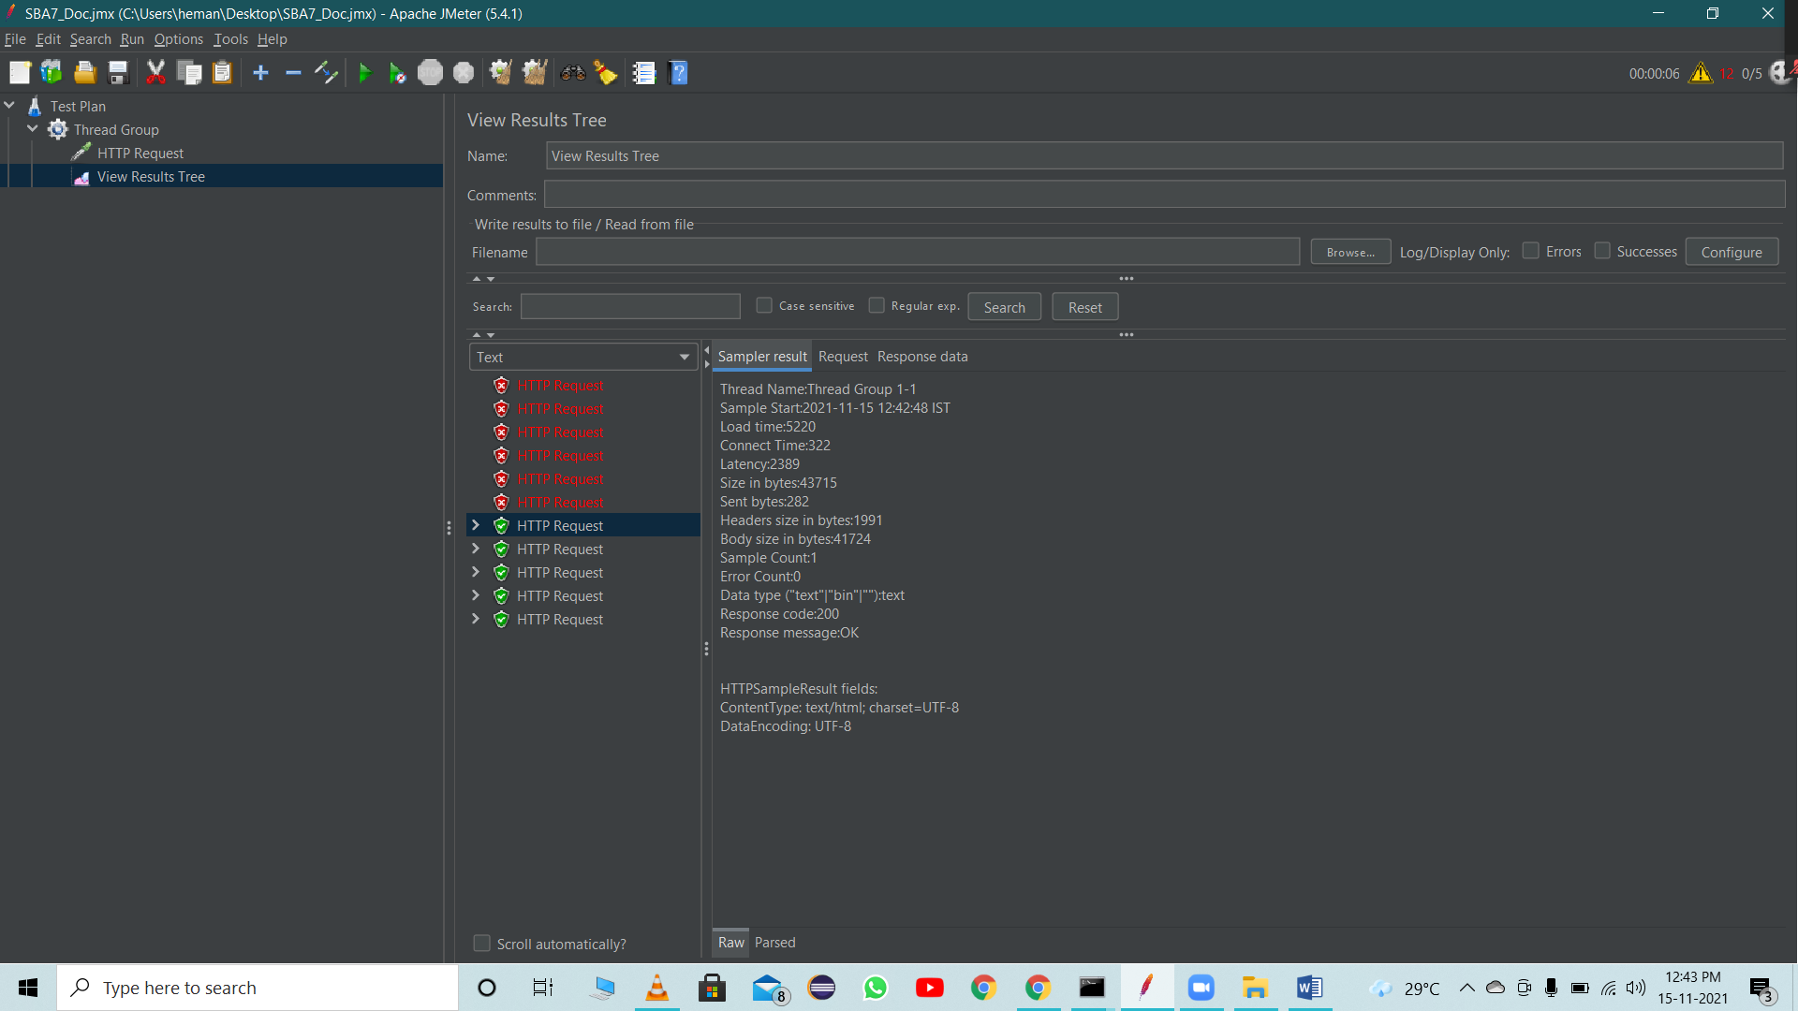

**JMeter Example-1**

Thread count increased to 5.

Here we will perform assertion check on success code

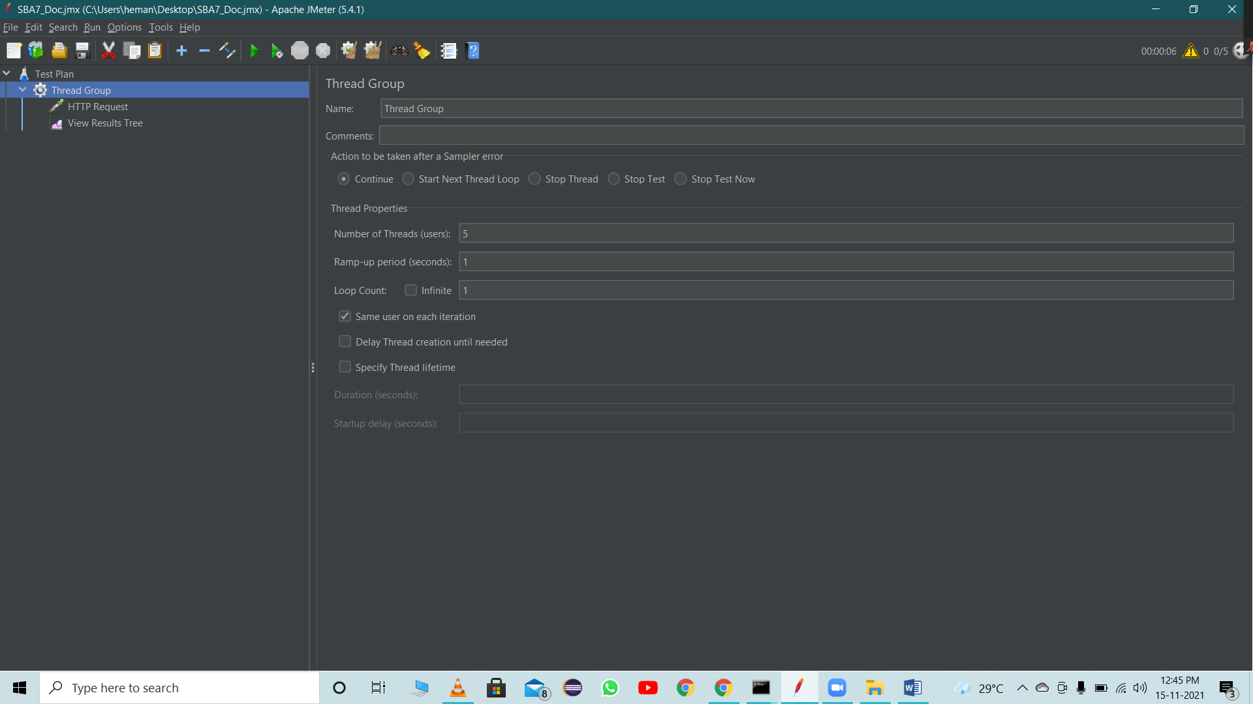

After adding the sampler

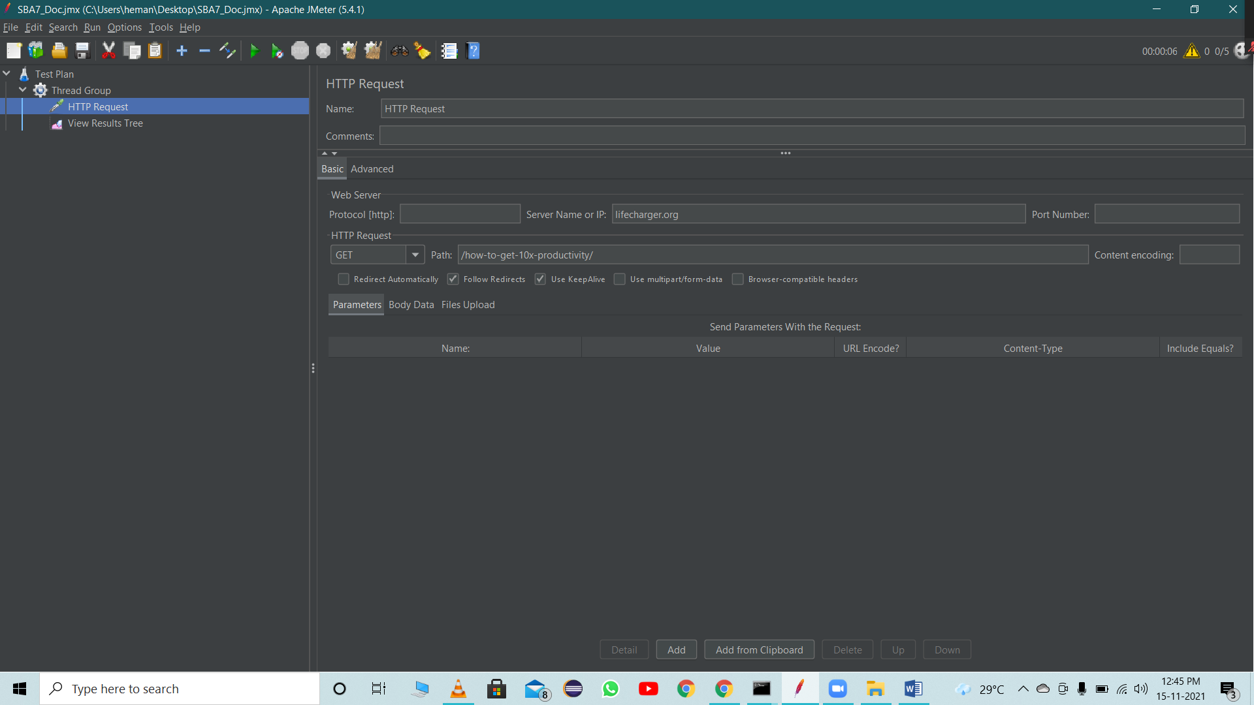

Result of the sampler after adding the Listener

After adding Response Assertion

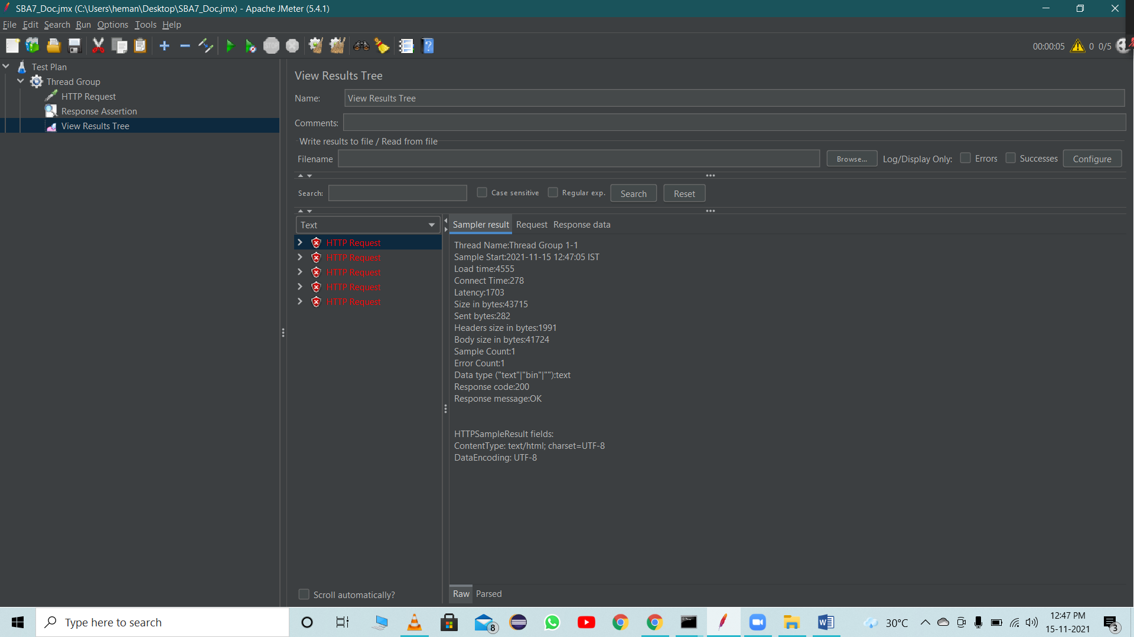

Result after changing the Response code to 201. Assertion check failed

**JMeter Example_2**

After Adding Thread Group

CSV Data Set Config

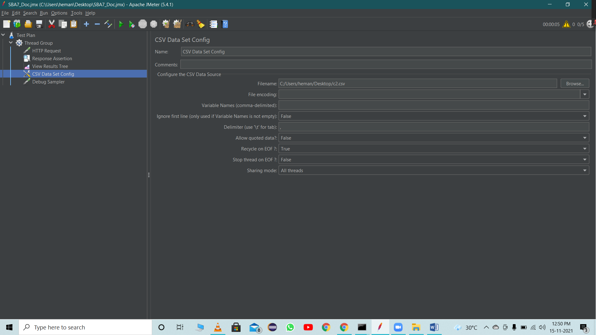

After adding Debug Sampler

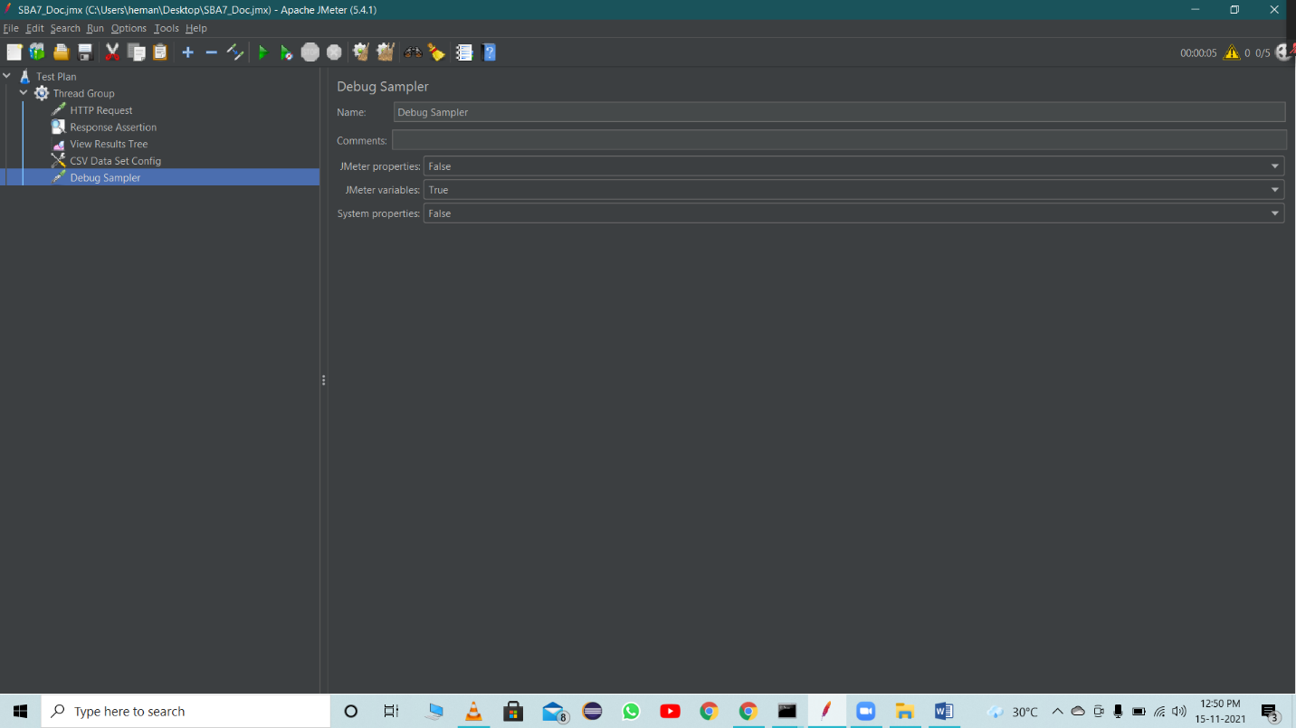

Result of Debug Sampler

View results table

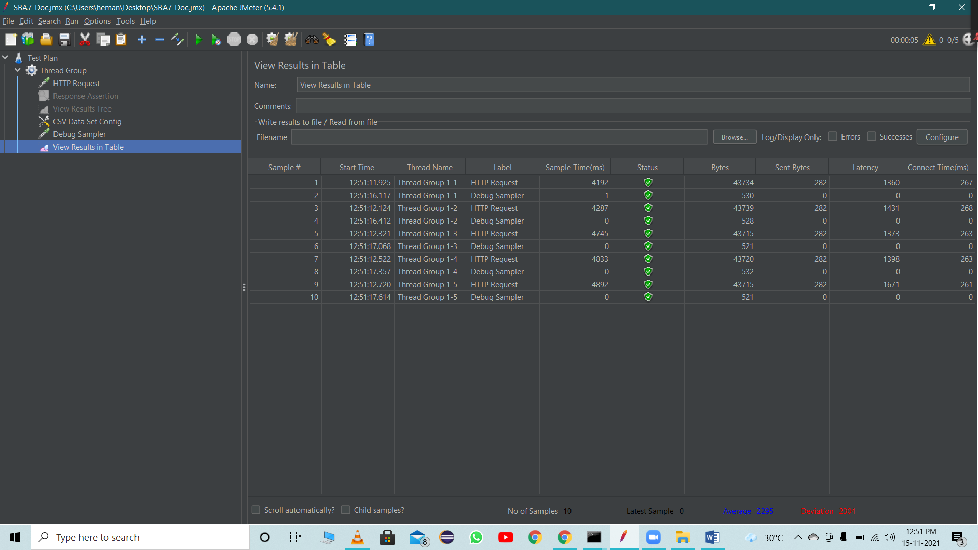

View results tree

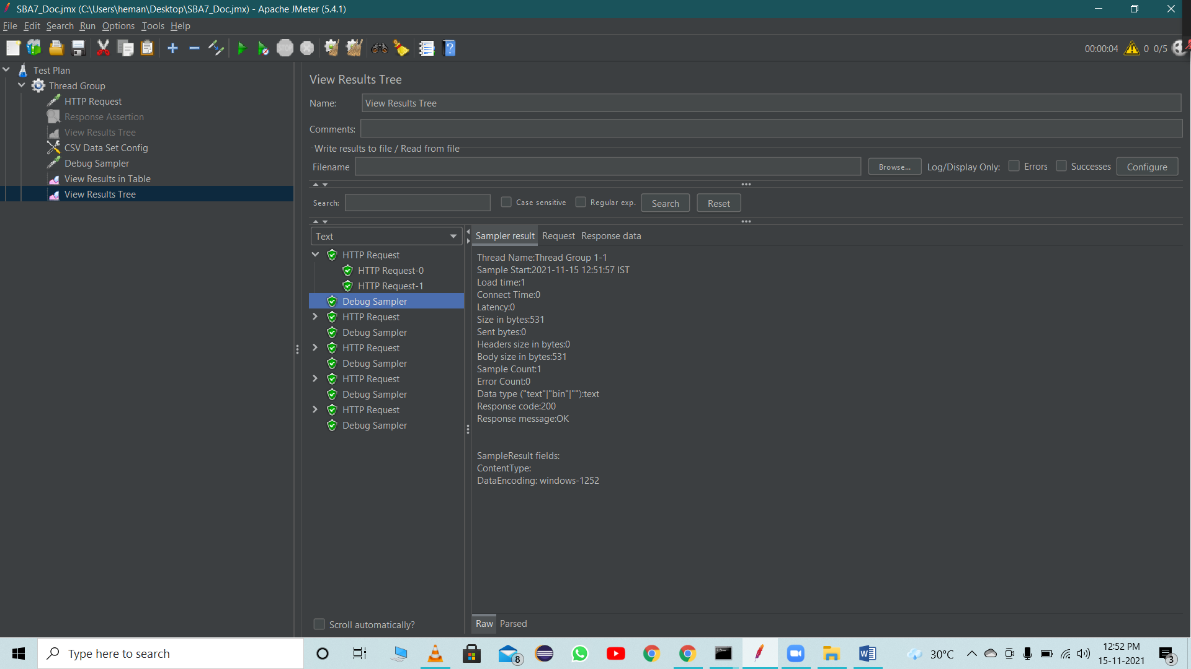

**JMeter Example_3**

After adding Thread group

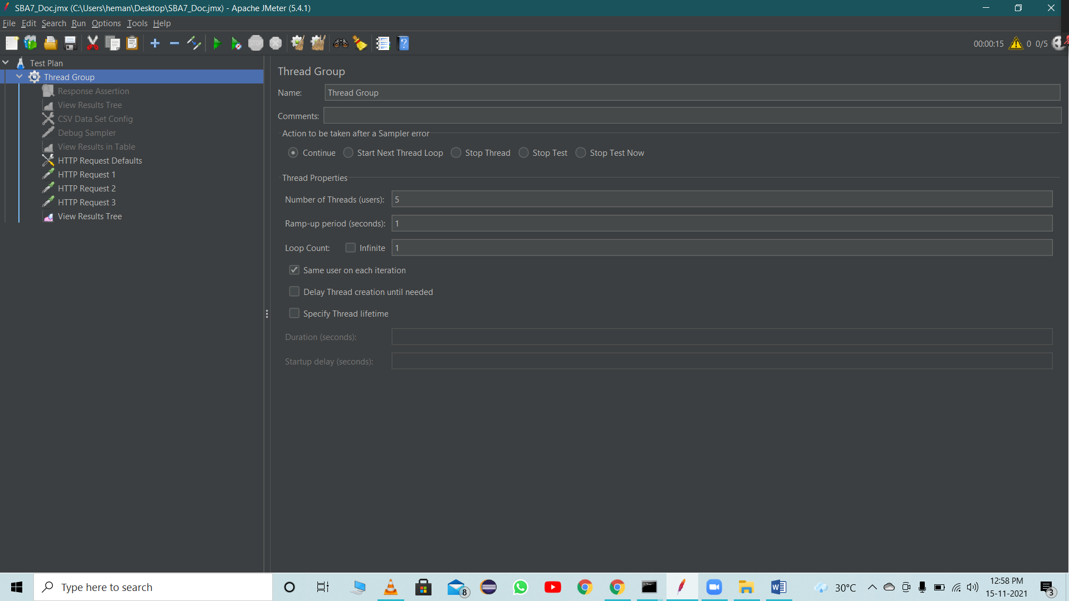

After adding HTTP Request Defaults. This will be applicable for all HTTP requests

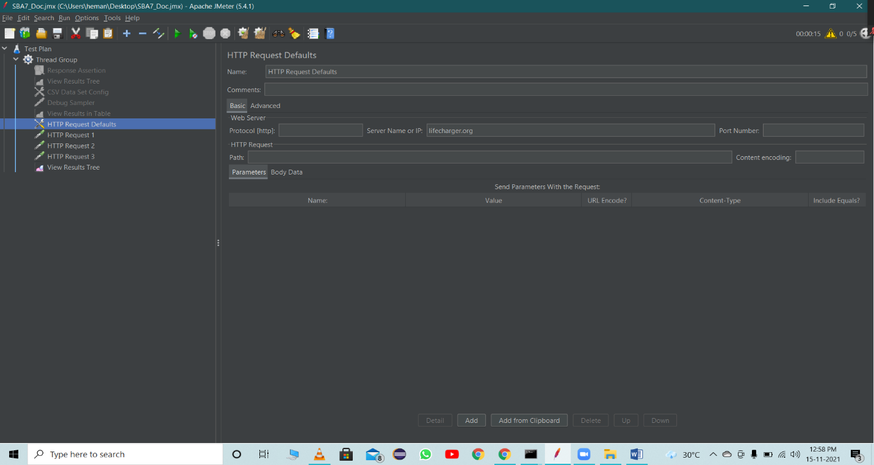

After adding Samplers HTTP Request

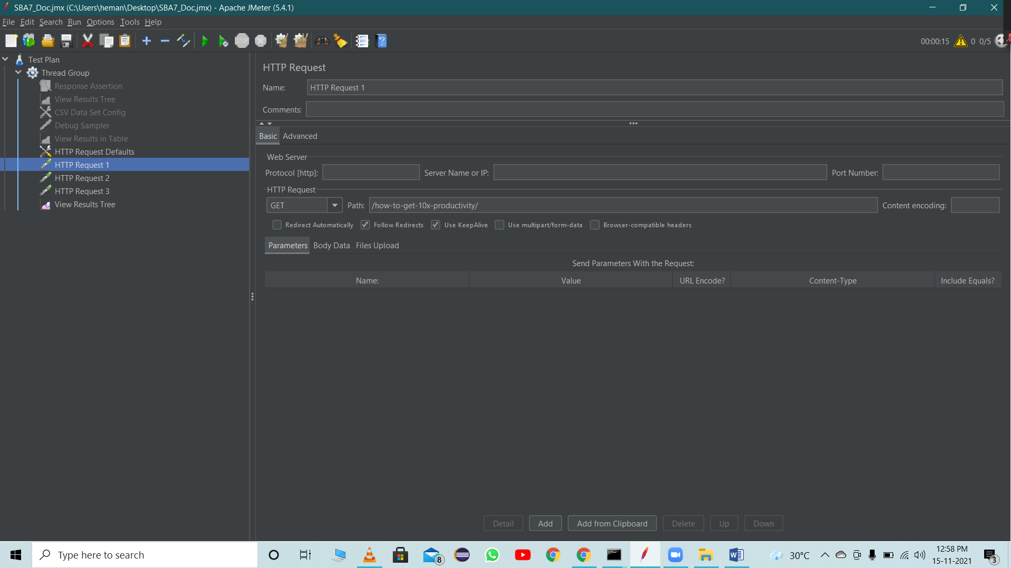





Result of HTTP Requests

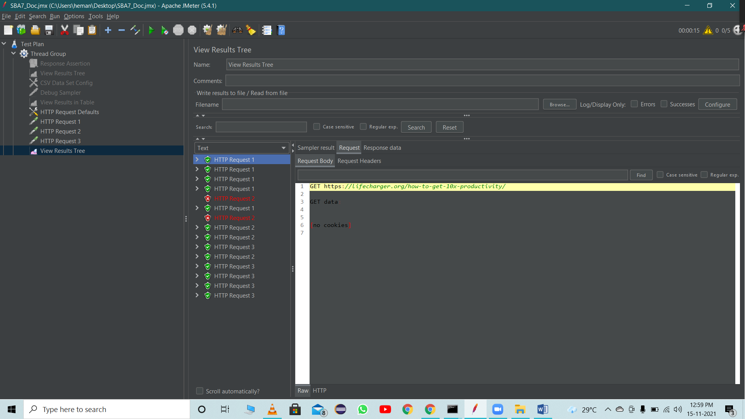



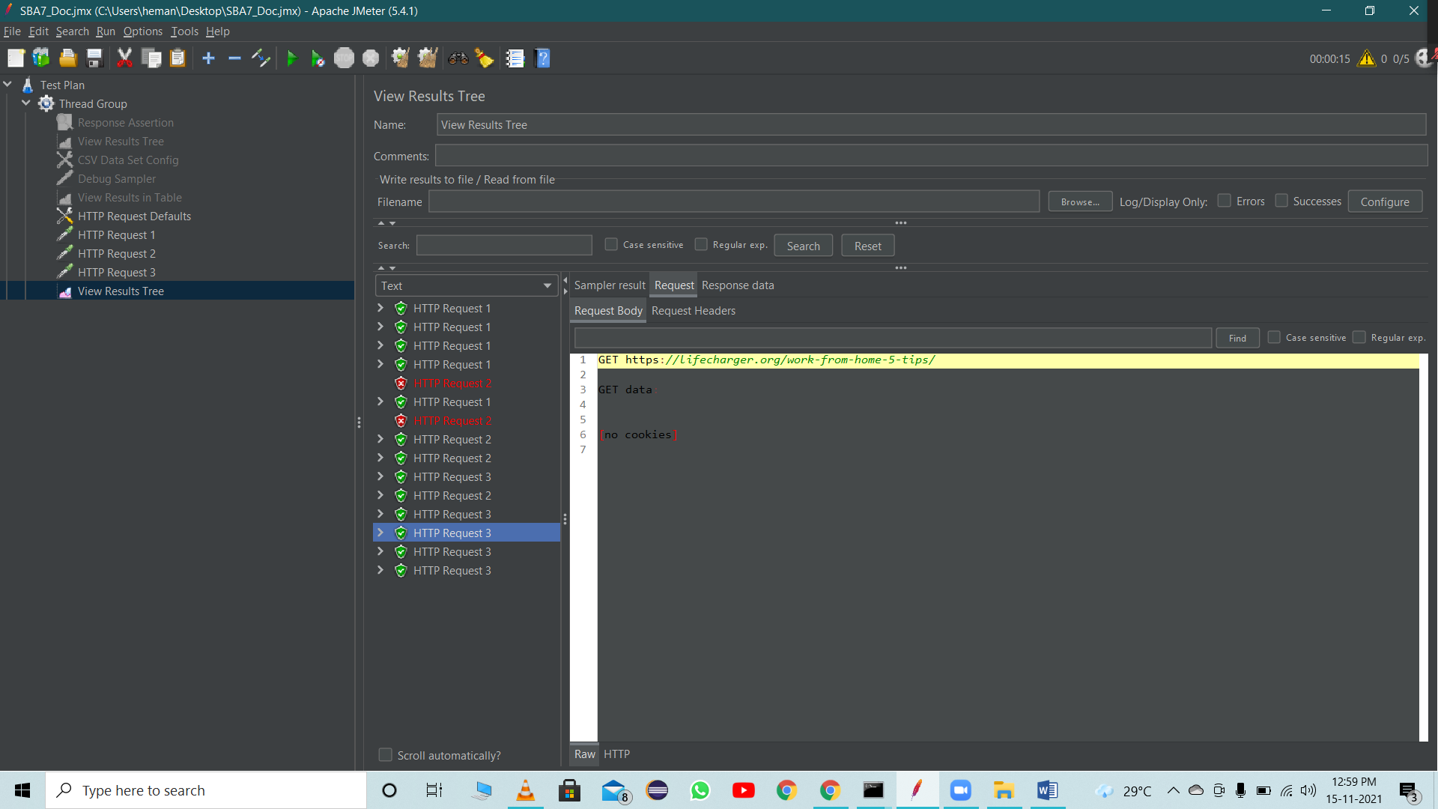

**JMeter Example_4**

After adding Thread Group

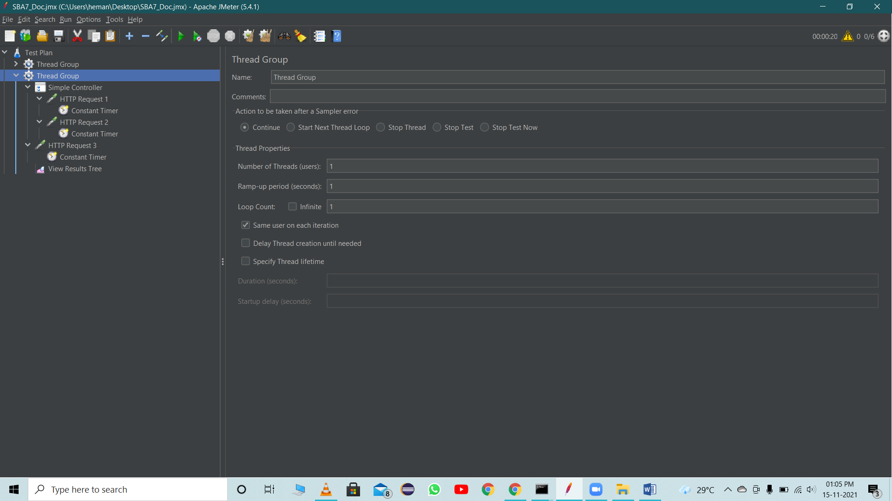

**After adding the simple Logic Controller**

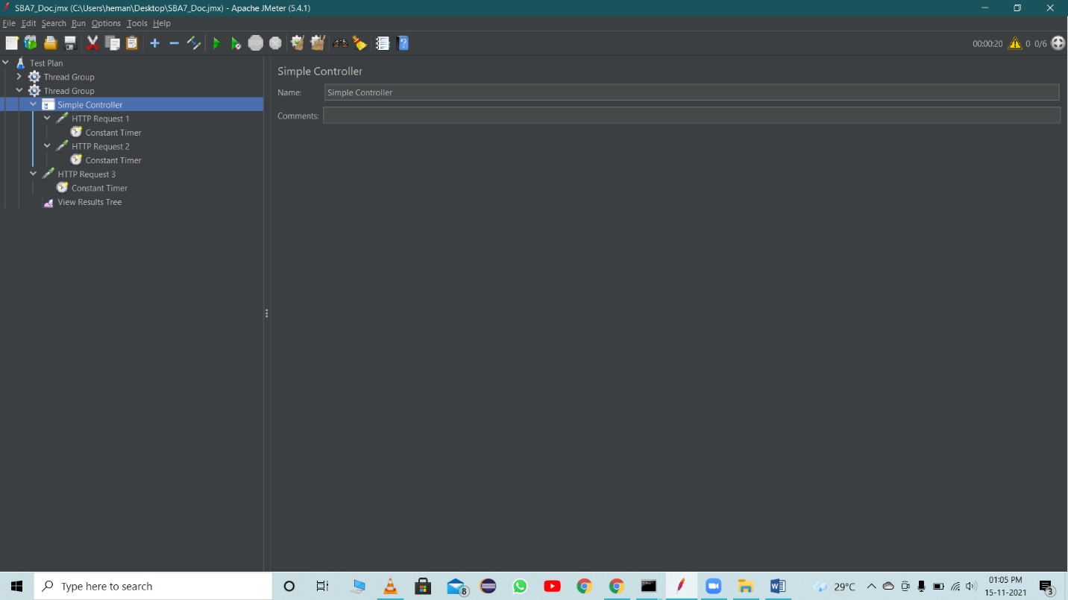

After adding First Sampler HTTP Request

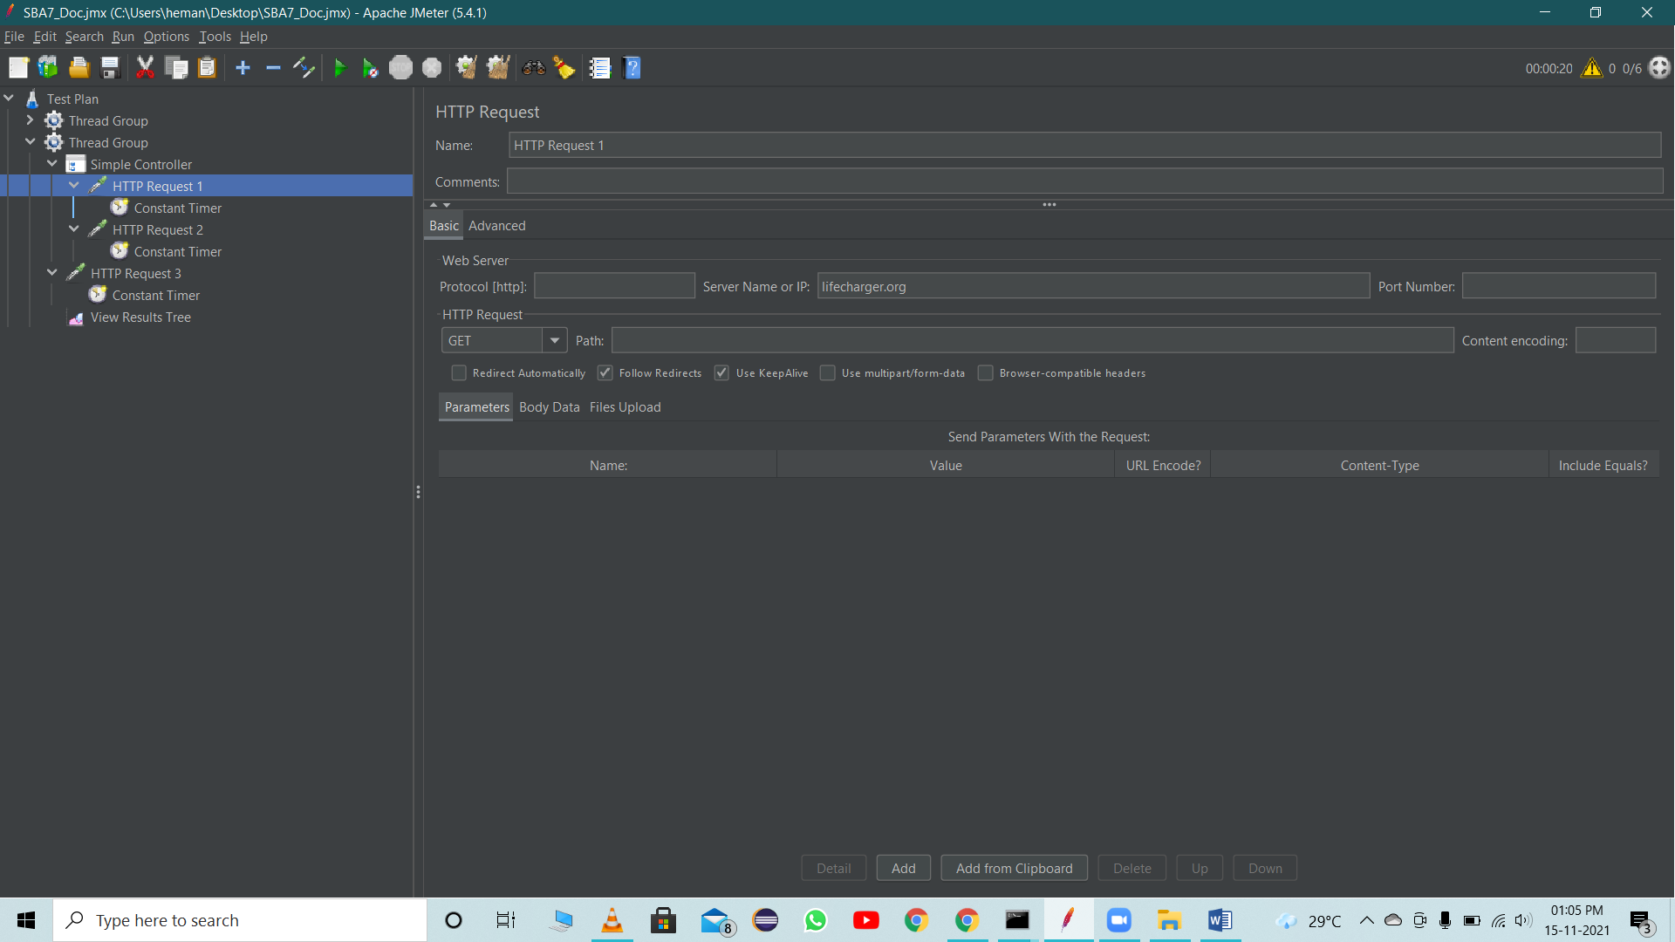

First Constant Timer

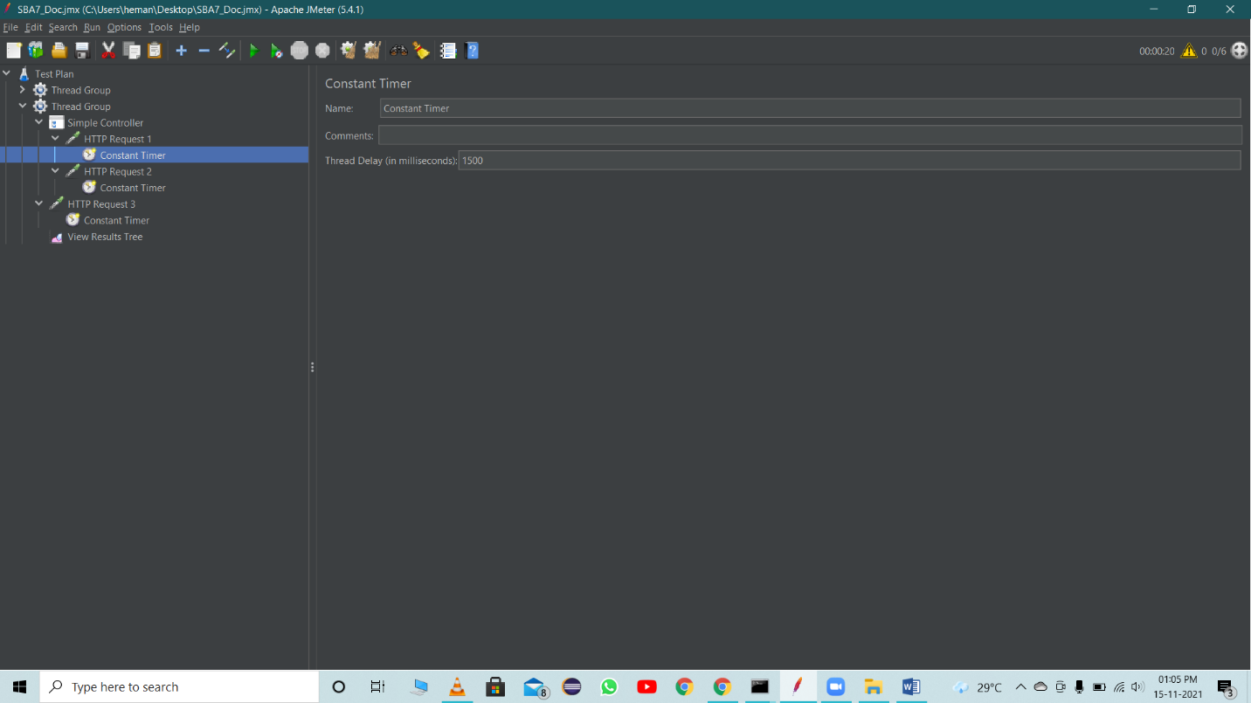

After adding the 2nd Sampler HTTP Request 2



Second Constant Timer

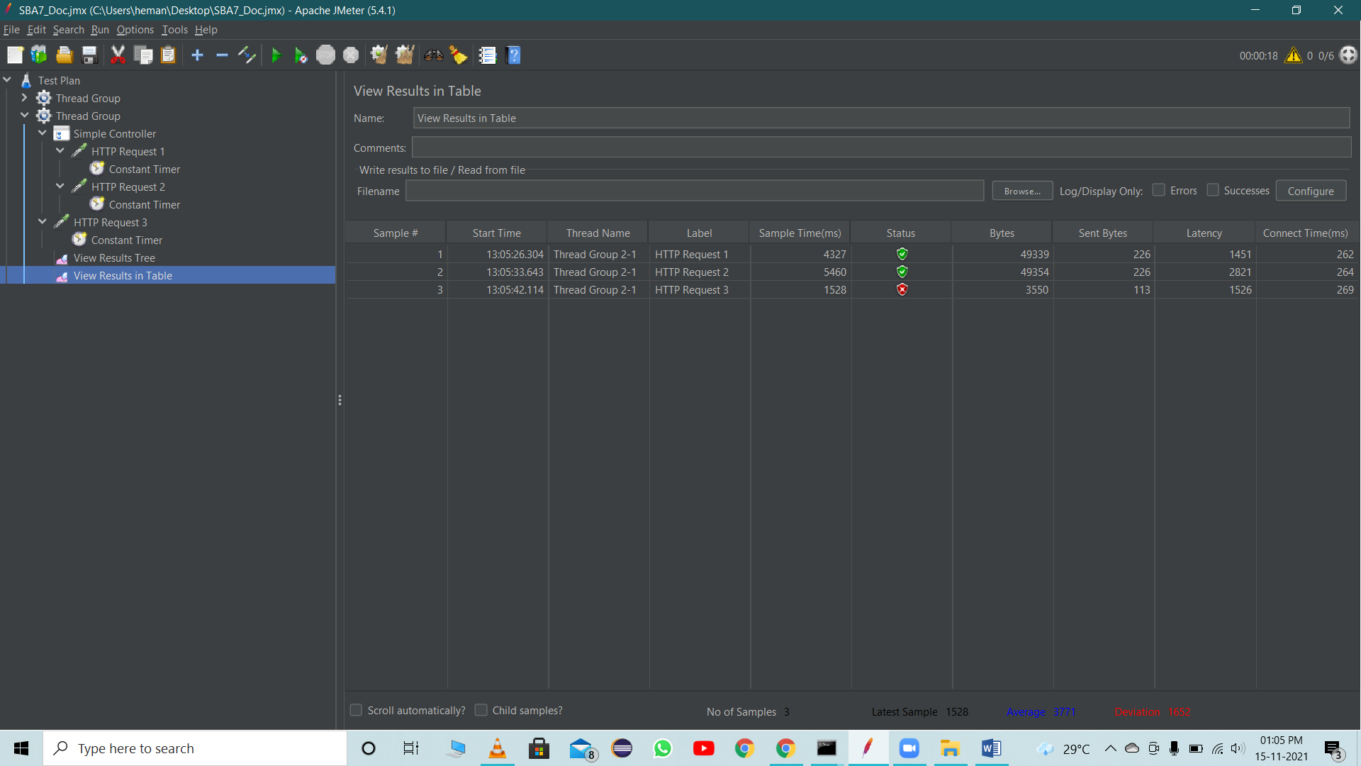

After adding the Third HTTP Request 3



Third Constant Timer



Result of the HTTP Request in the Table format

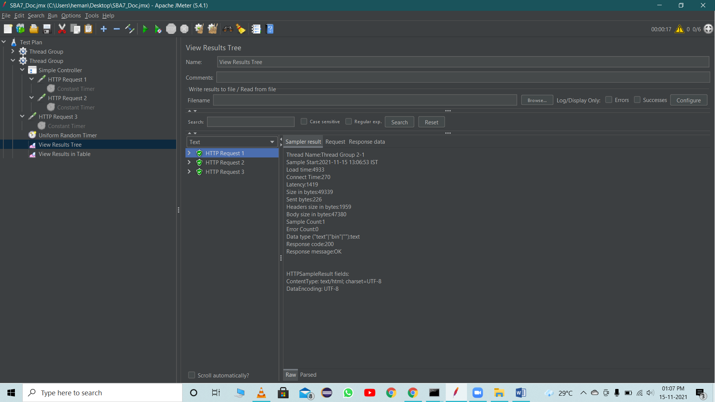

After disable all the Constant Timer and added the Uniform Random Timer

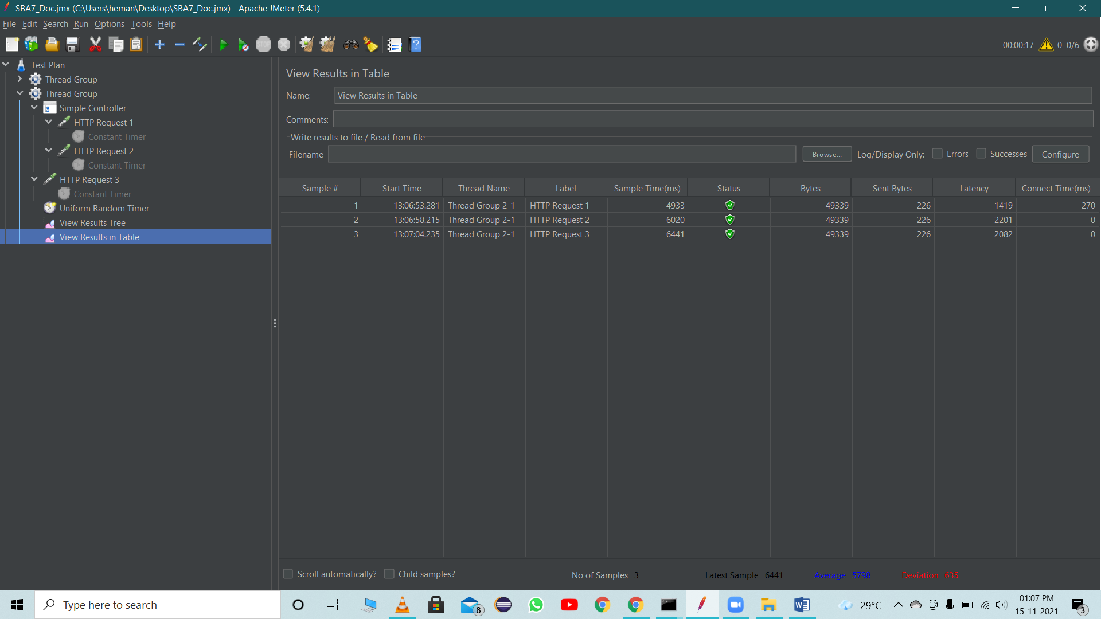

Result After adding Uniform Random Timer



**Logic Controllers**

Logic controller helps us define the order of request which need to be executed in the JMeter.

Steps:

* Create a new Test plan.
* Add new Thread Group.
* Add Two HTTP Request.
* Add a Listener.
* Change the loop number of tread to execute as 2
* Run the test

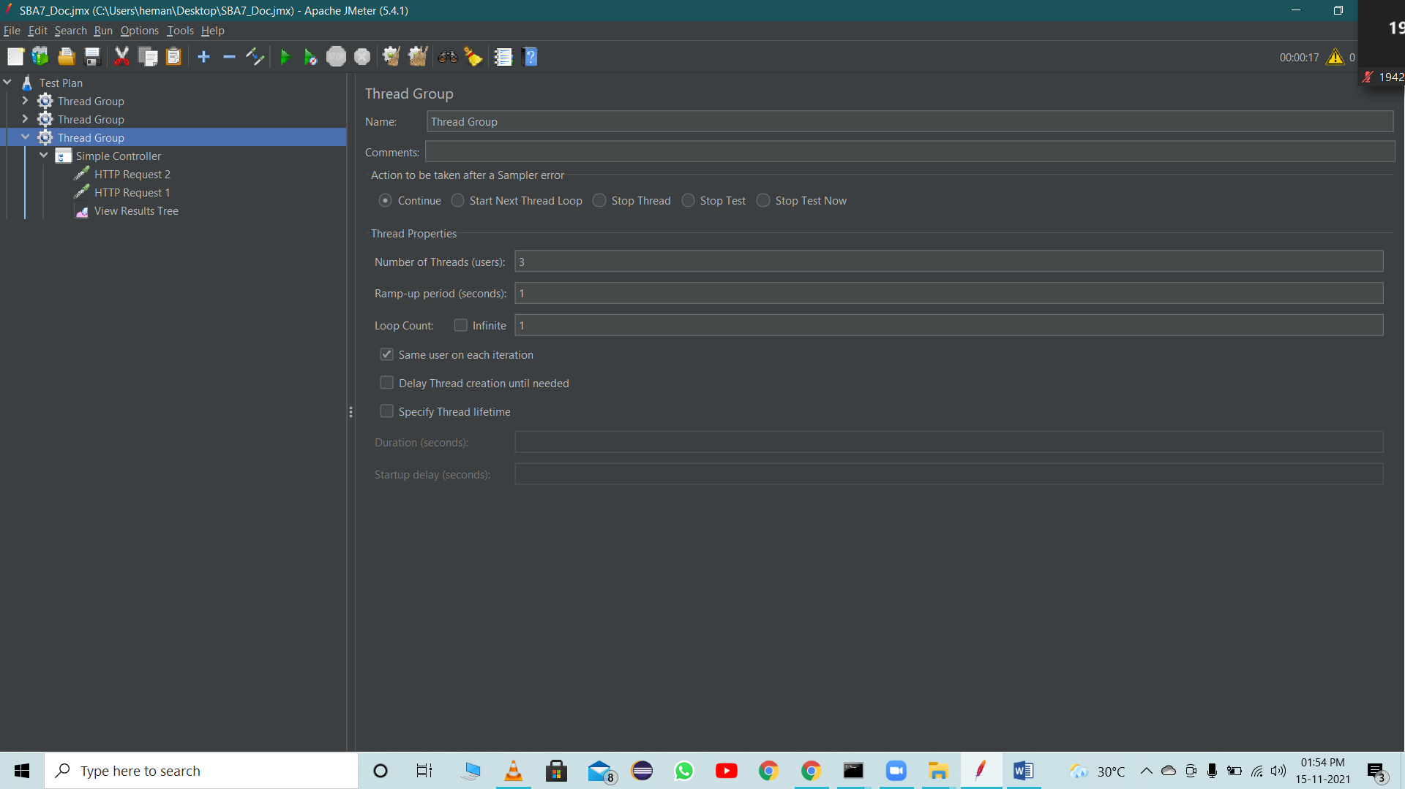

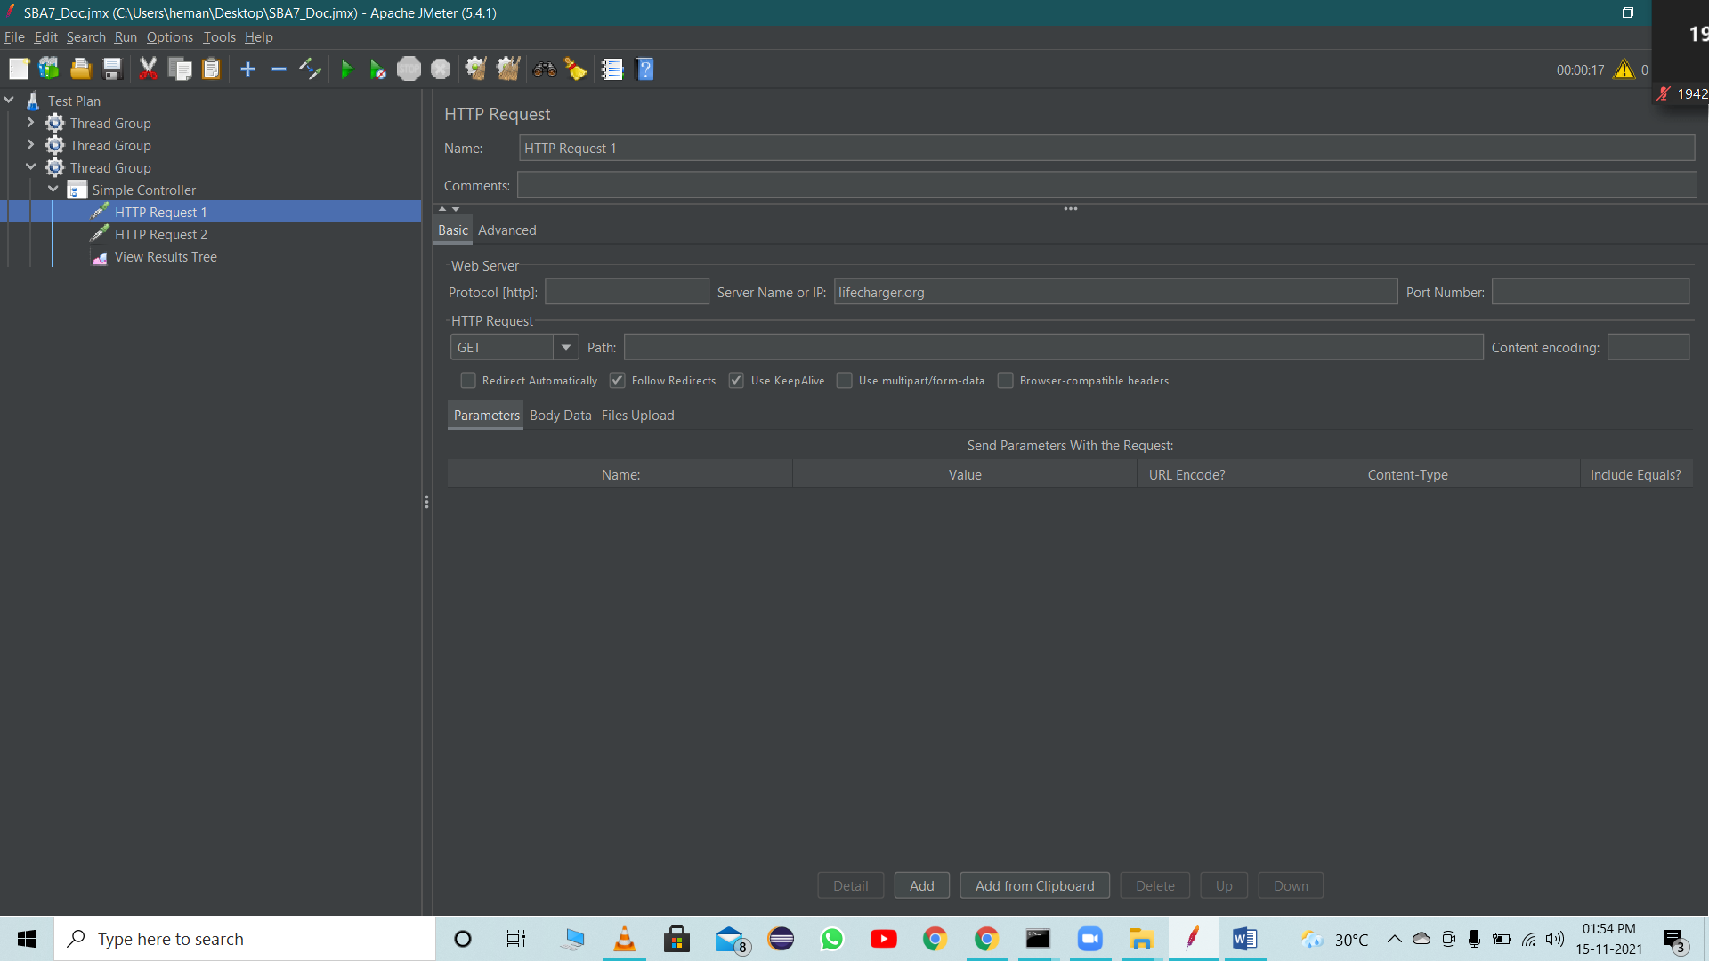

* Add Logic Controller – Simple Controller

Simple Controller doesn’t provide any functionality its just a container that contains user request.

Simple controller group the Thread request

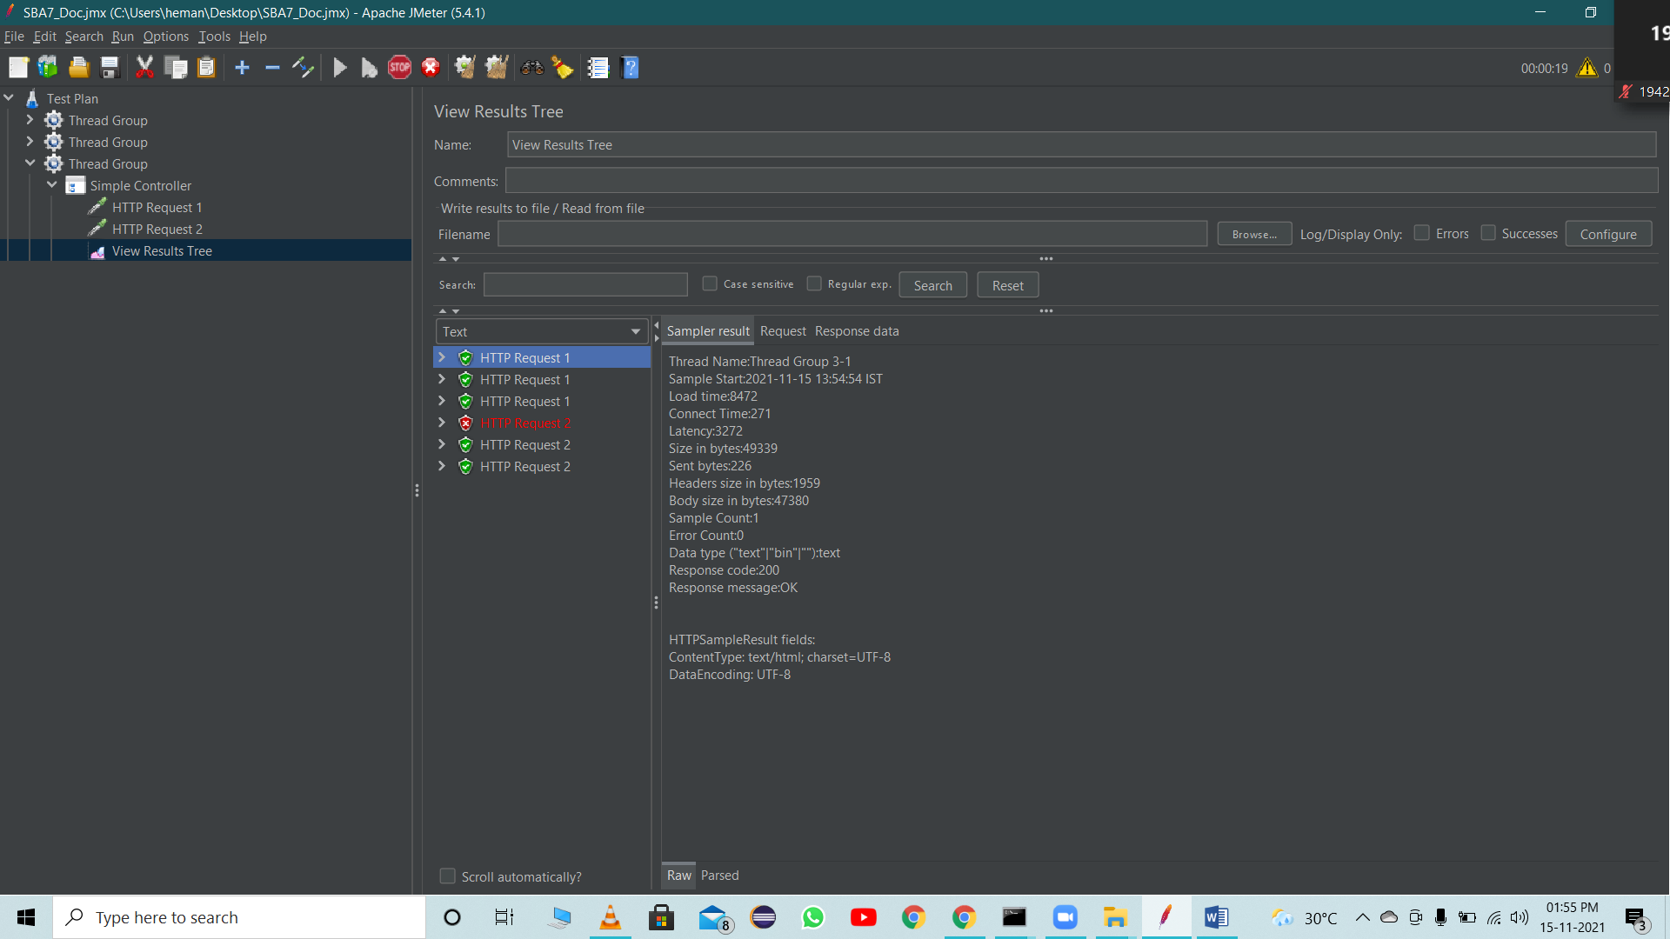

Add Once Only Controller

Once Only Controller provides functionality to run any user request to run only once per loop. Add once only controller to thread group by using below steps.

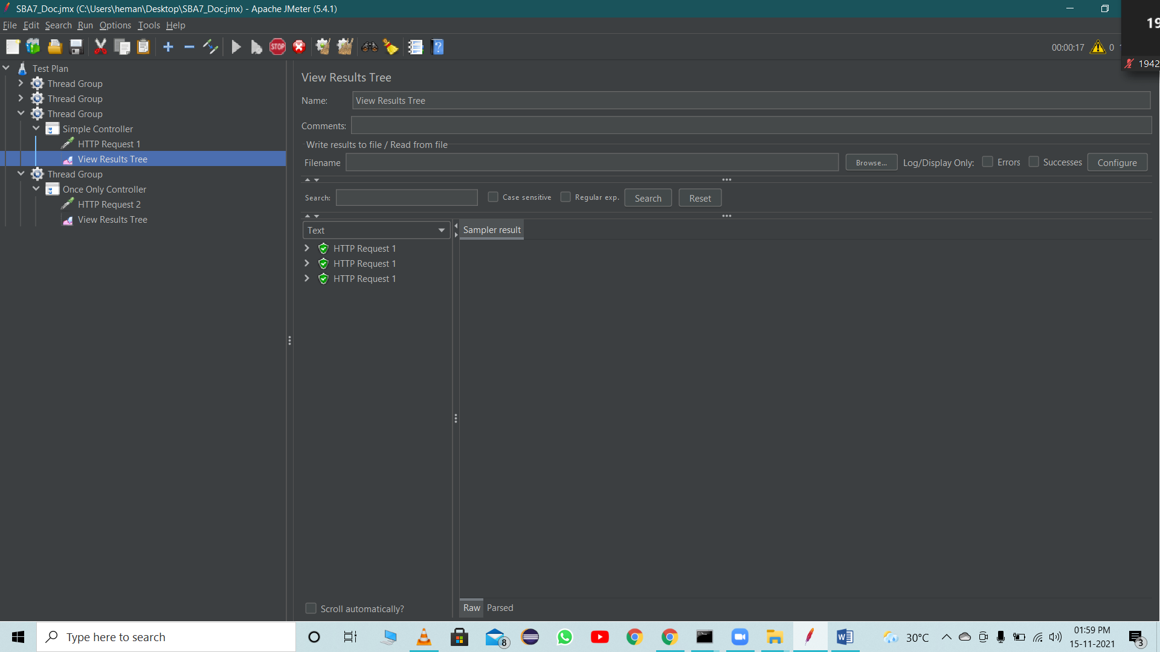

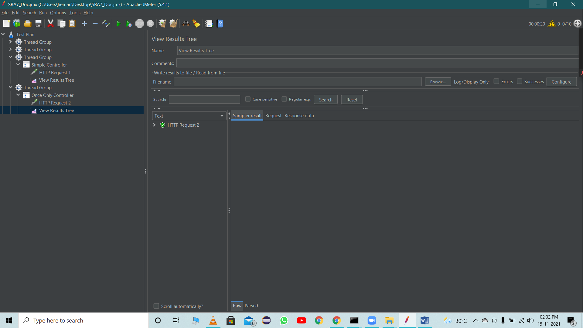

Module Controller

Module Controller provides functionality to run which module needs to run. Add module controller to thread group by using below steps.

Examle:-

Creating some Scenario:

1.login and search a product

2.login and order a product

3.login and cancel order

Steps:

* Create a new Test Plan
* Create 3 Thread Group for 3 Scenario
* Create HTTP requestes
* Add a Listener

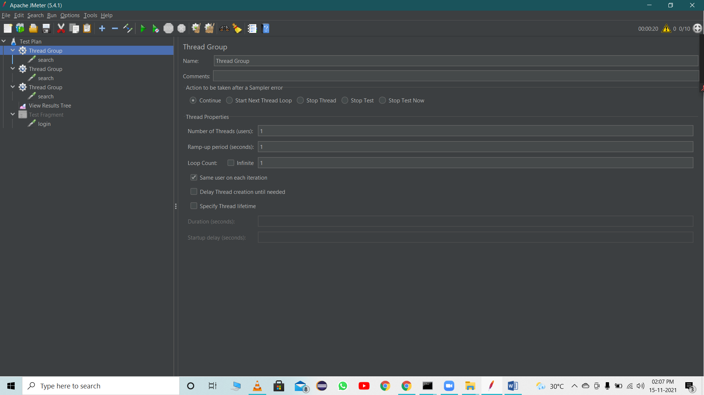

* Add Test Fragment

Test Fragment element is a special controller which can be added directly under JMeter test plan like Thread Group. But It does nothing except holding other elements inside!! It gets executed only when it is referenced by a Module/Include controller from other Thread Groups.

Place the request inside it [repeating Request is login]

Request gets executed when called from controller like module controller/include controller

* Add Module controller

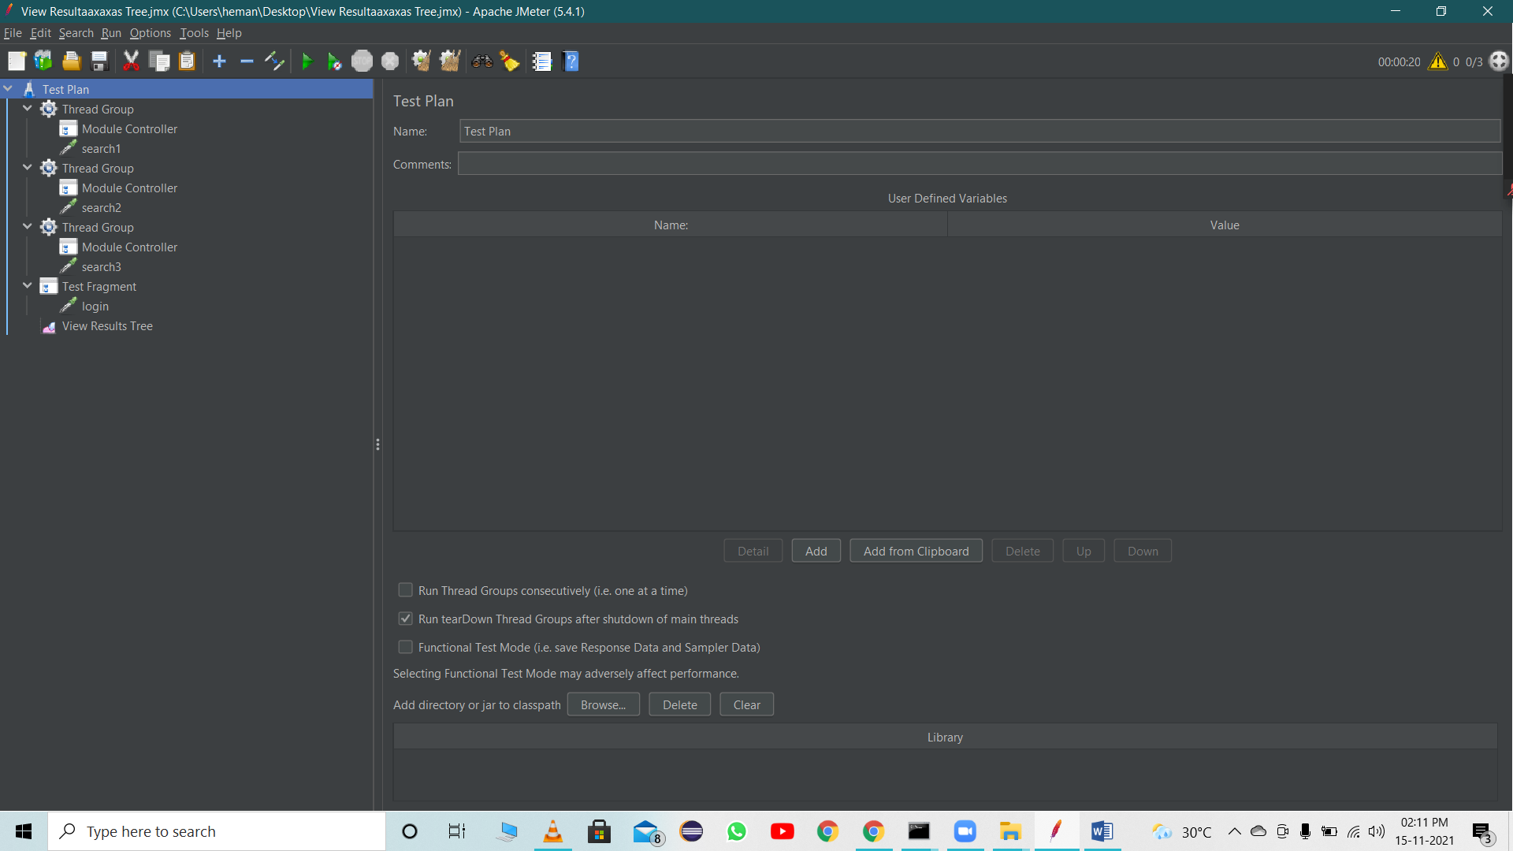

Select Test fragment

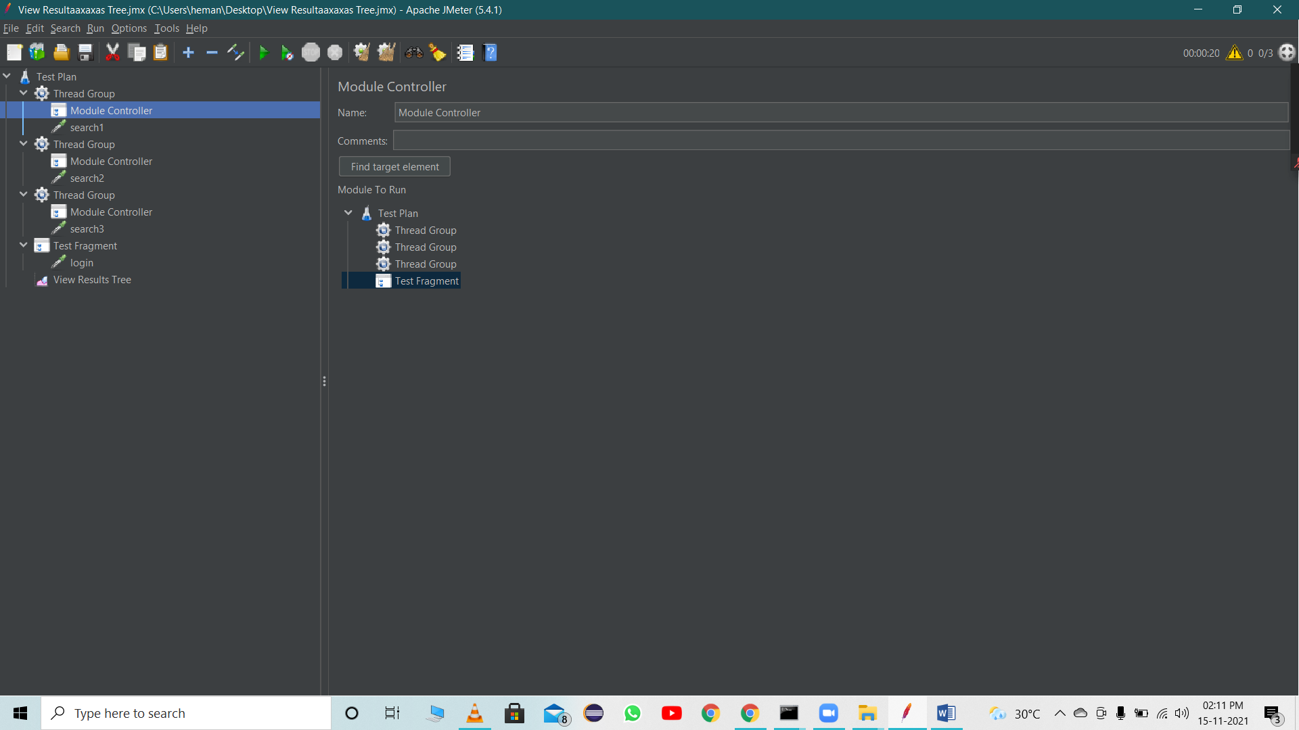

Add controller in all Thread group [because every thread group has login]

Run the Test plan [Same as previous Tread]

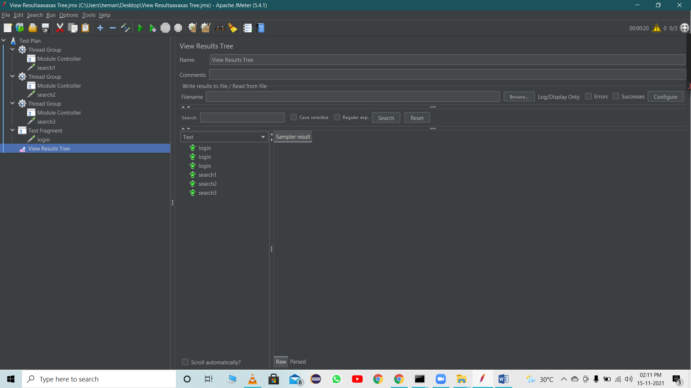

**Include Controller**

Include controller of JMeter is very useful if you want to break your test plan in small fragments. There are many different jmeter controllers available. Each of them has a different purpose as per its name.

Include controller is useful to include external test fragments in your test. Means you can include external test fragment in your software load test plan using include controller.

Include controller provides you the facility to use external test fragments in your test plan. So you have to save login steps as a test fragment and then you can use that test fragment in your all software load test plans using Include Controller

Example:

Scenario

1.Login

2.Search product

4.Cancel Product

Steps:

* Add Thread Group
* Save login as JMX file for include controller

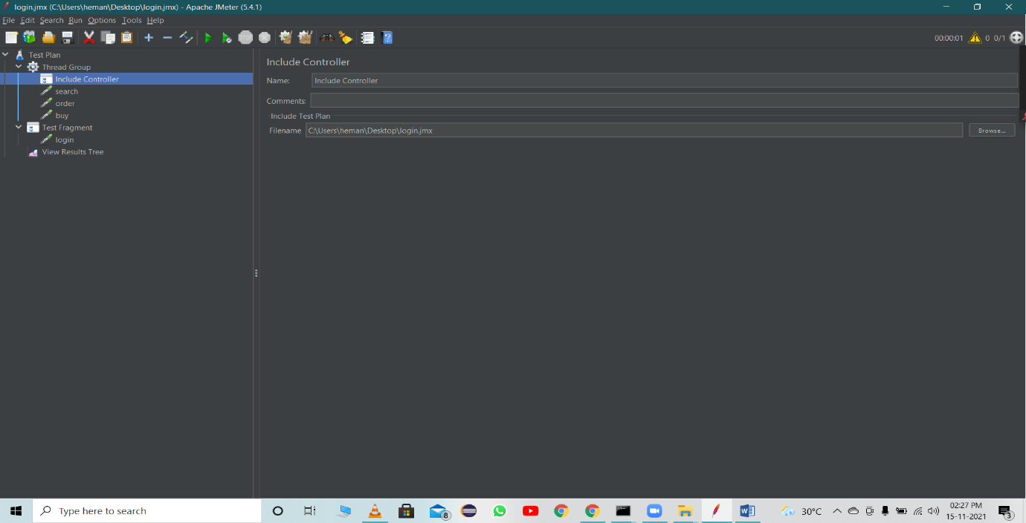

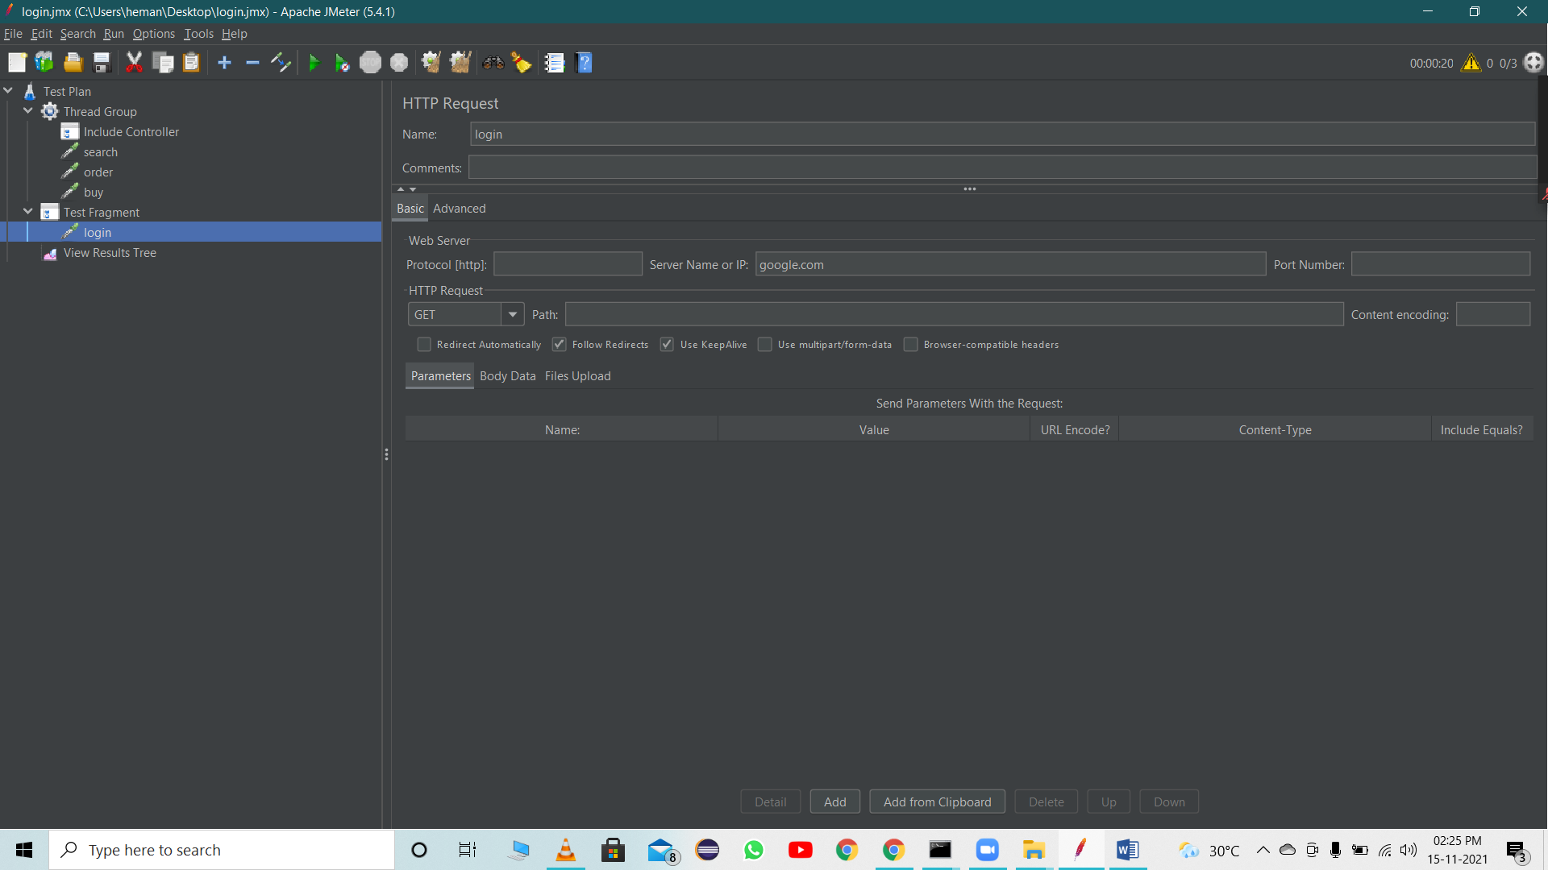

* Add include controller inside Thread group

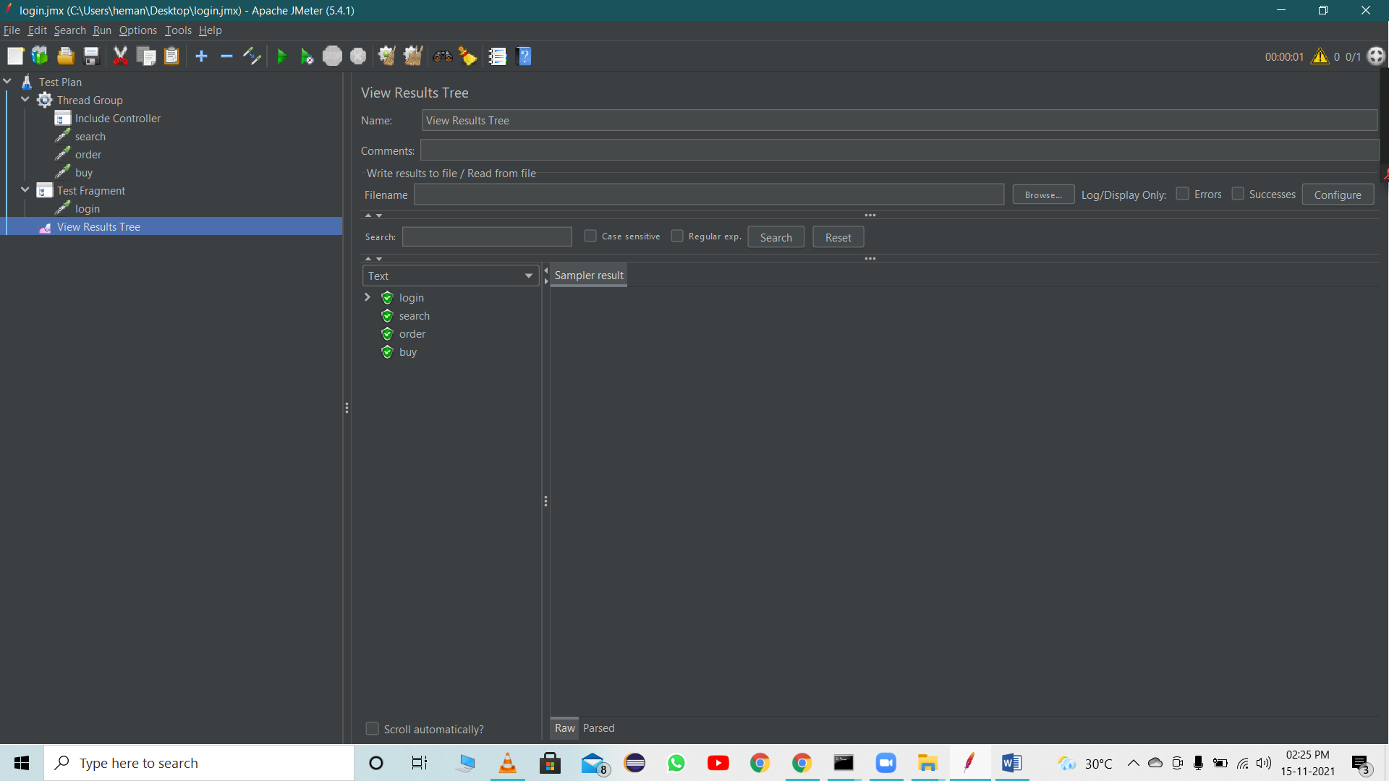

* Add File
* Add requests inside the Thread Group and Run

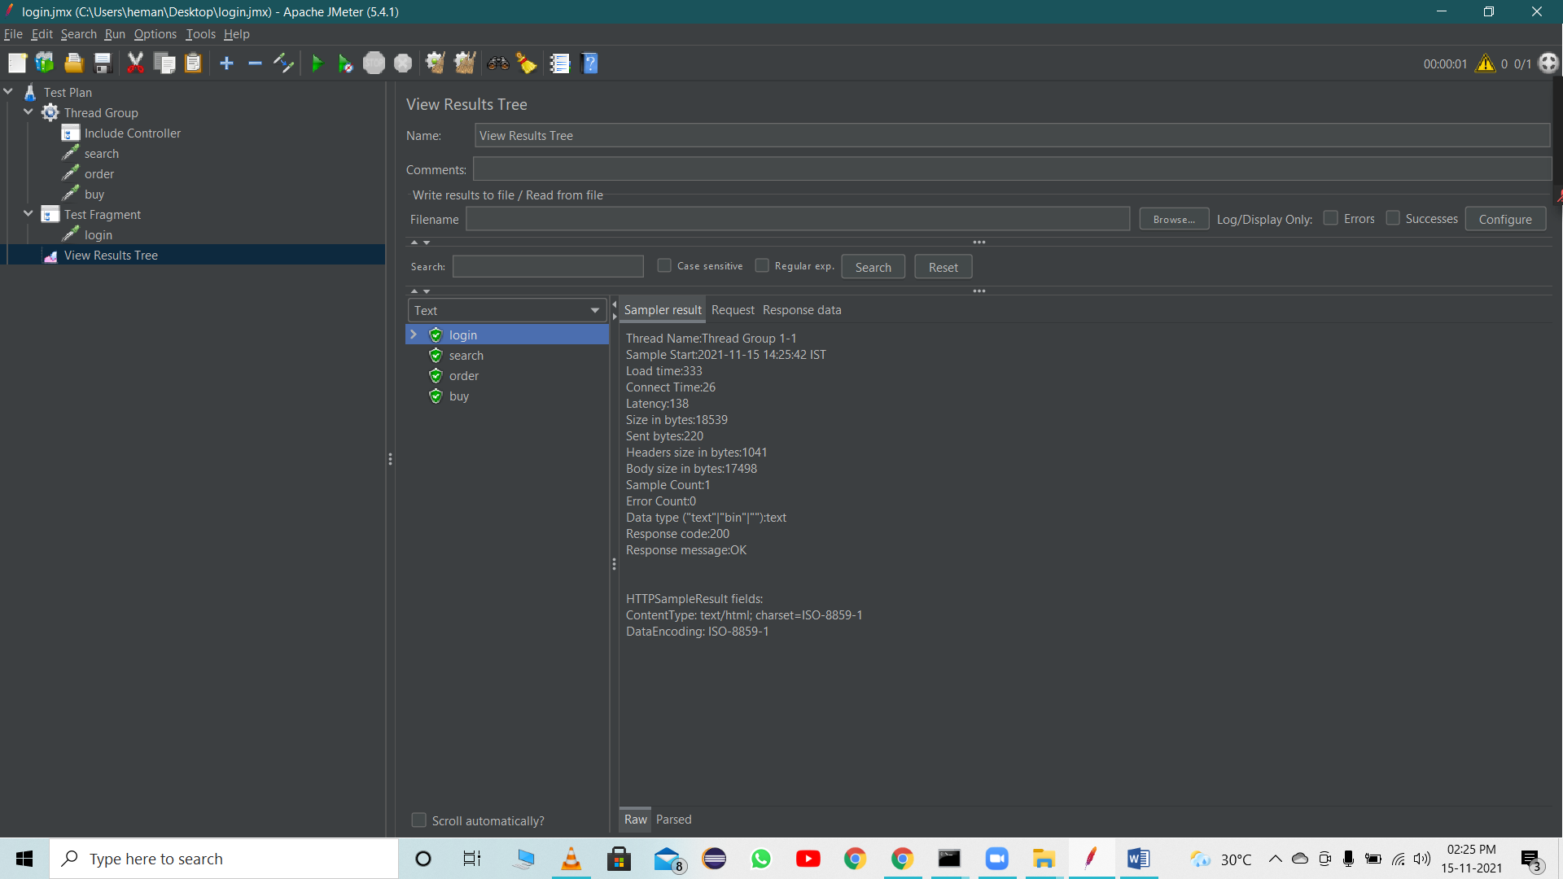

**JMeter Pre & Post Processors**

Pre Processor executes before the sampler execution. Post Processors are used to execute the response data from the server and to save the specific extracted values for later use.

User parameter

The User Parameters PreProcessor specifies user input parameters specific to individual threads. For each thread, the variable value will be used based on the order of that user thread in sequence.

Steps:

* Create a Thread group
* Add pre processor – User Parameters

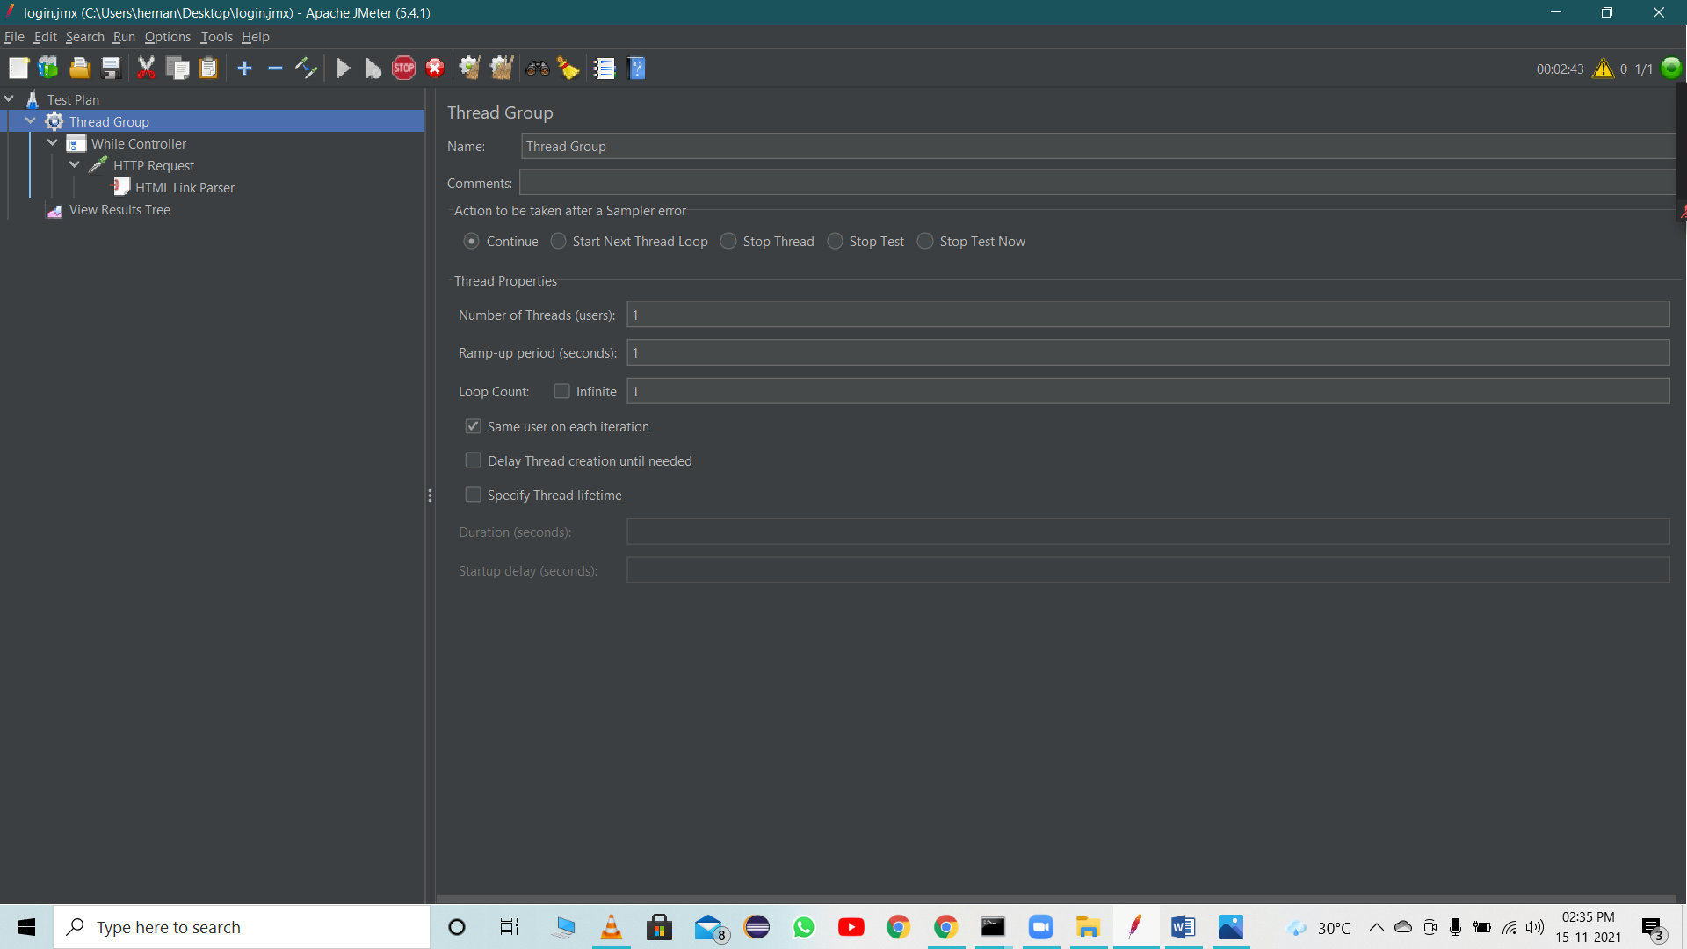

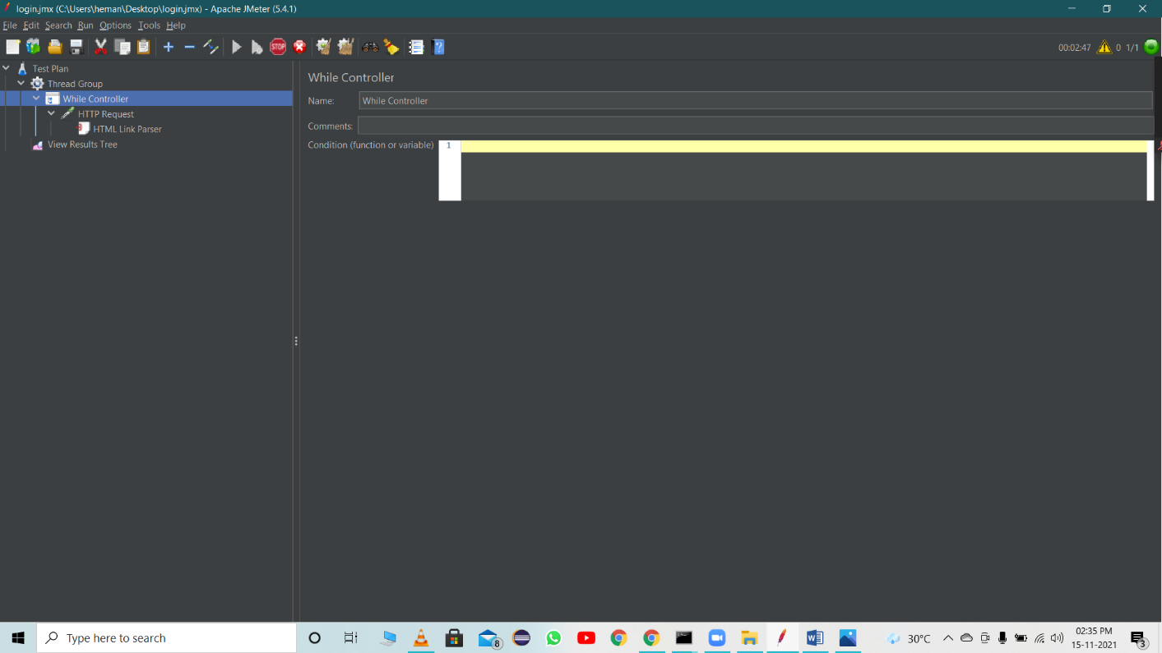

* Add Request

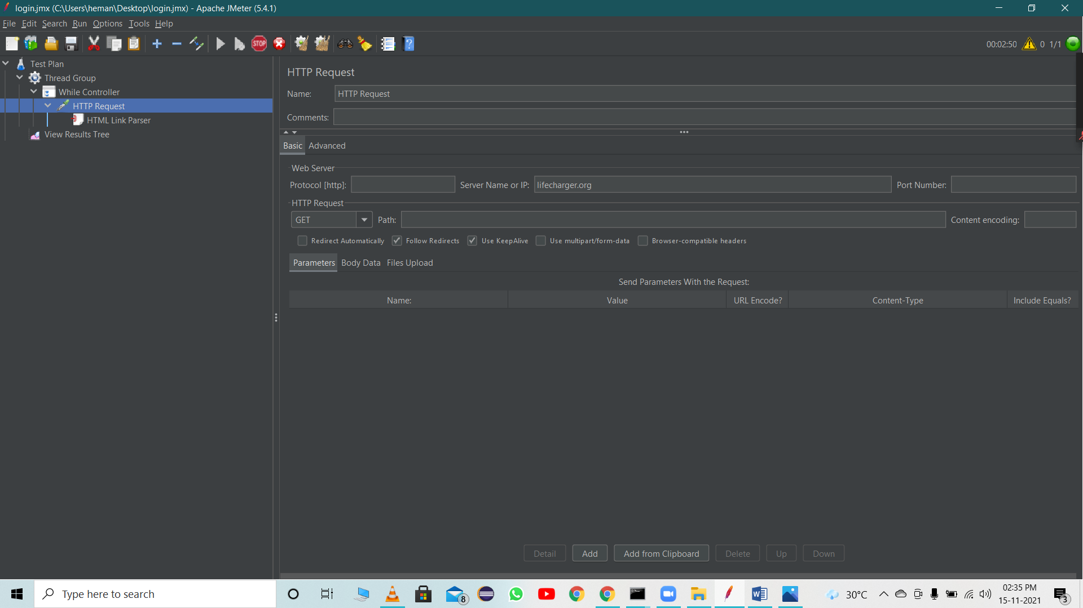

* Run

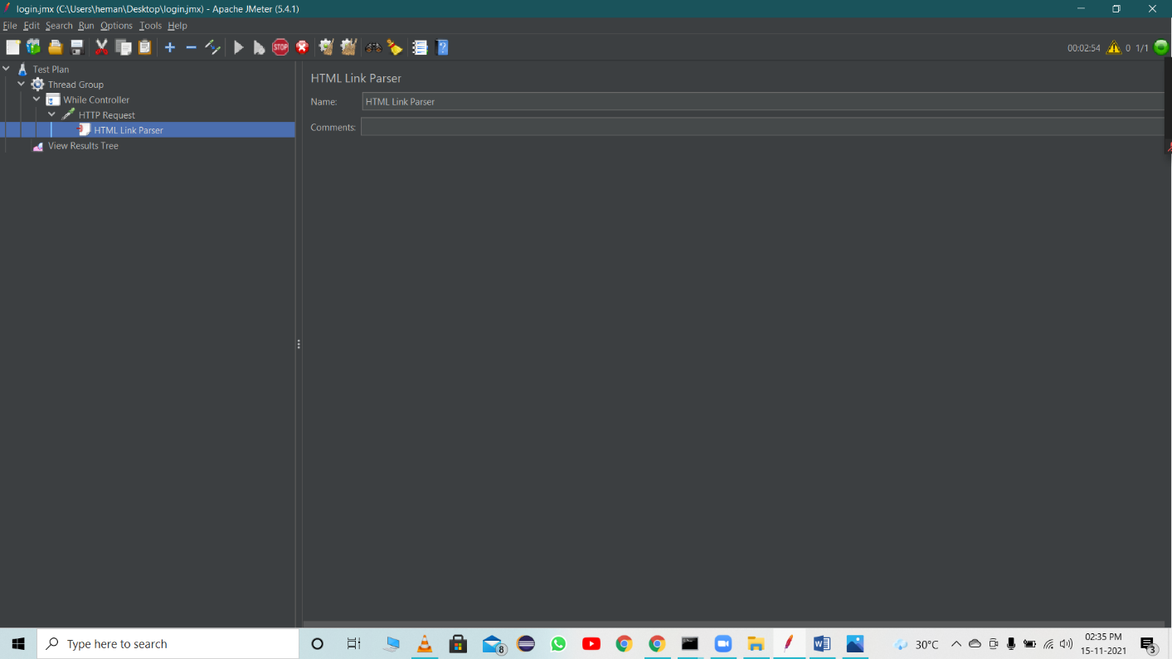

HTML Link Parser

The HTML Link Parser PreProcessor can be used to parse a response, extract all the found links and request them further. This can be useful when the main goal of your script is to simulate web crawling.

Steps:

* Create a Thread Group
* Add a HTTP Request
* Add another HTTP Request and add HTML Link Parser inside the request

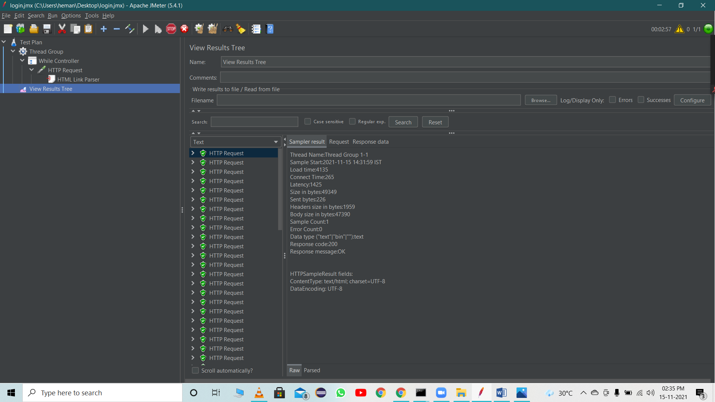

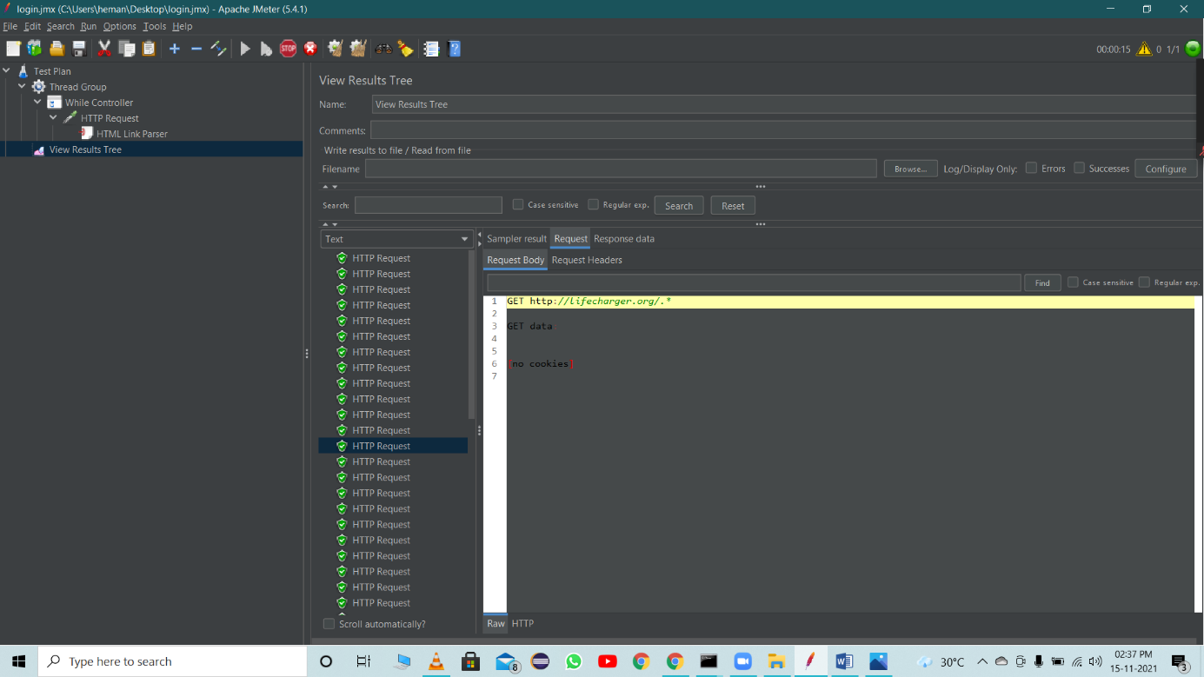

**Post-Processors**

Post-Processors are actions that are performed after your sampler has been executed. You can use them to perform some actions on your response or extract some values out from the response and save them in a variable that can be used later.

Result Status Action Handler:

Result Status Action handler let the user select the action to be taken when sampler gets any error.

Below actions can be taken:

* Continue
* Start next thread loop
* Stop thread
* Stop test
* Stop test now
* Break Current loop
* Go to the next iteration of the current loop

Steps:

* Create Thread Group
* Crete two Java Request
* Add Post Processor - Result Status Action Handler

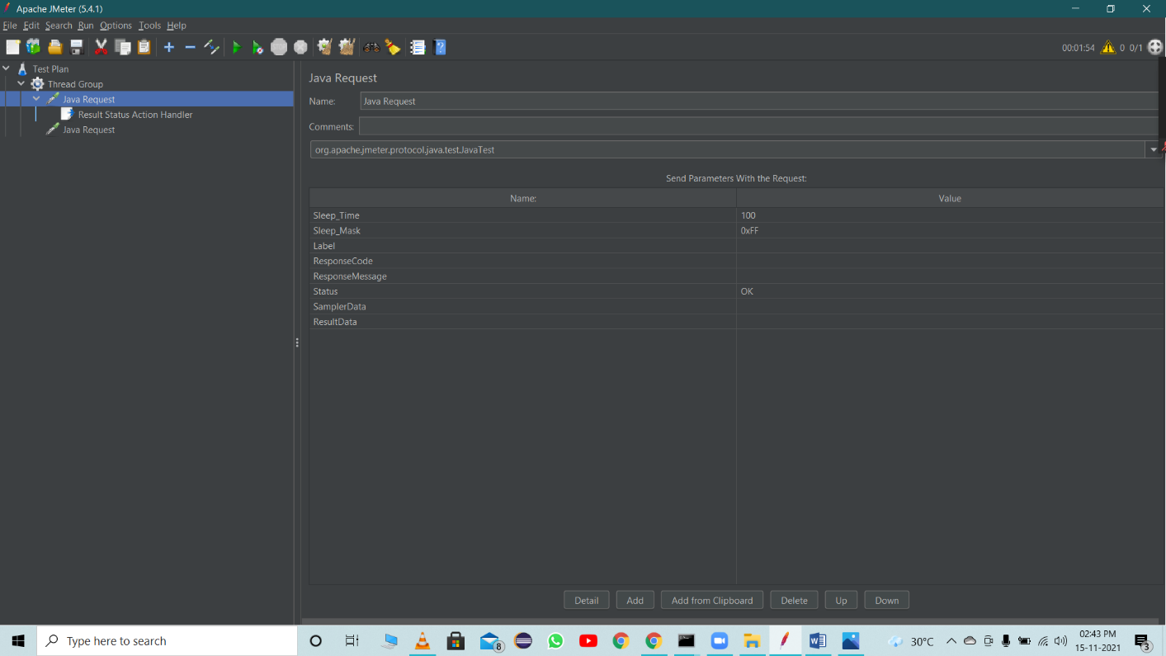

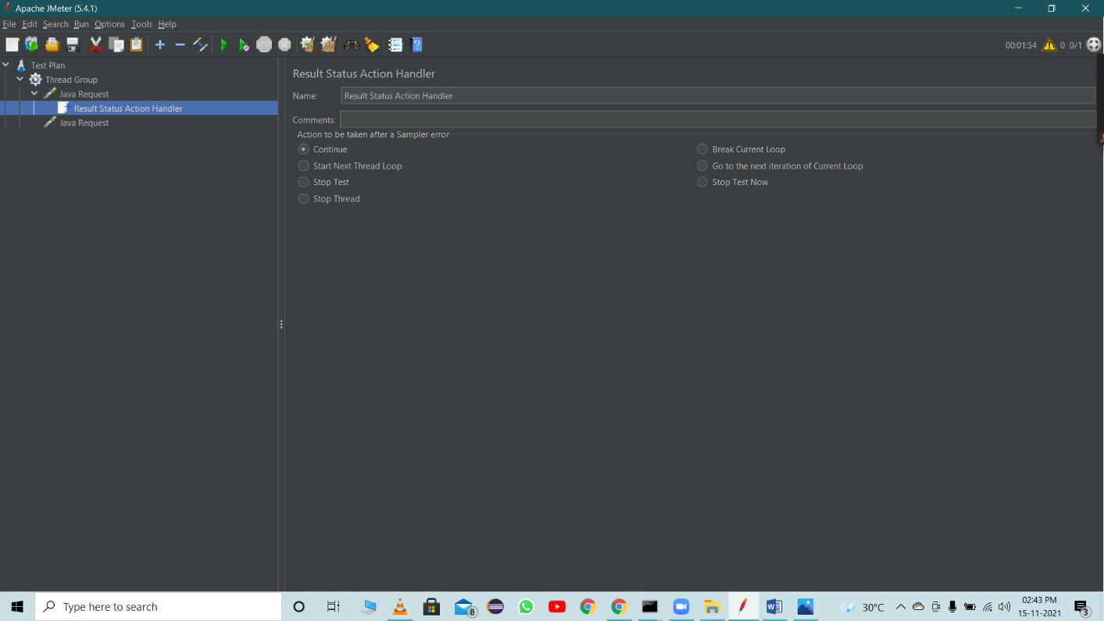

**JMeter Variables And Functions**

Function – methods used to populate fields in any other elements of a test plan

Syntax :

${__functionName}

${__functionName(var1,var2,…)}

Variables – Containers that can store values, which can be referred in any element within a thread.

Syntax :

${varName}

Steps:

* Create Thread Group
* Add Java Request

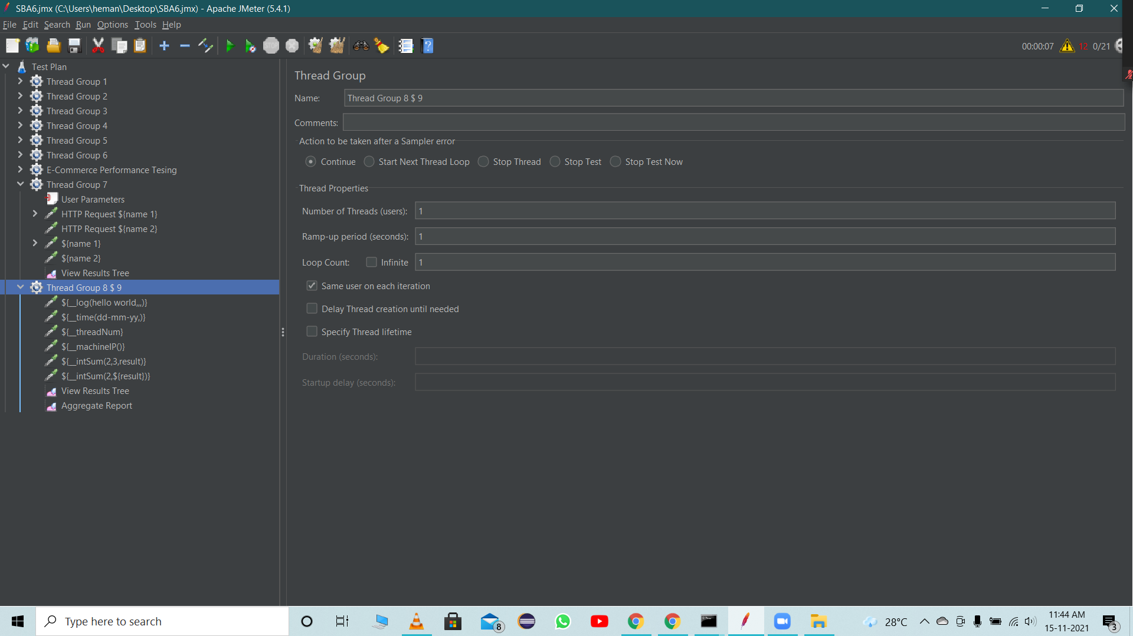

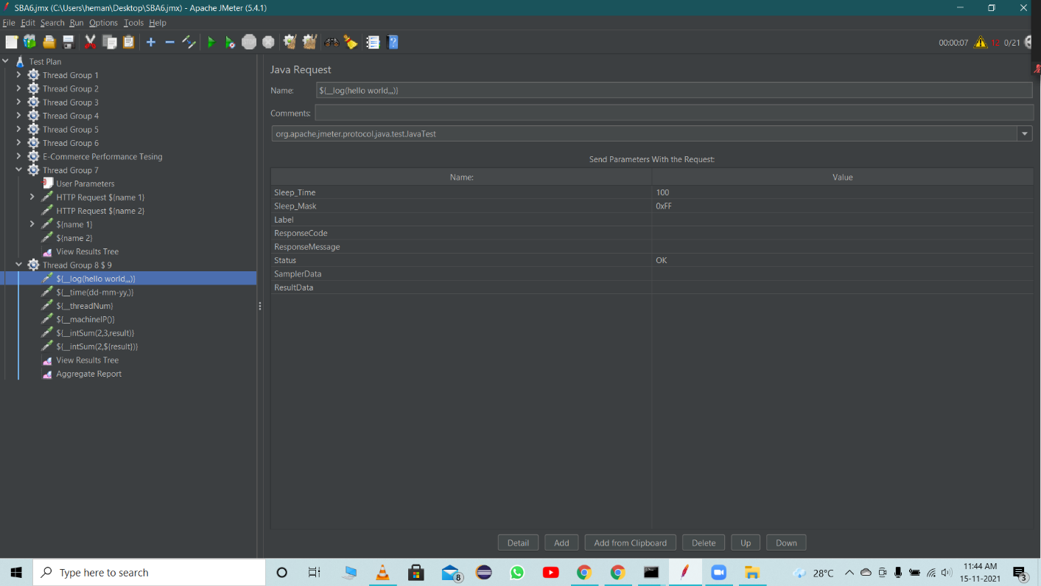

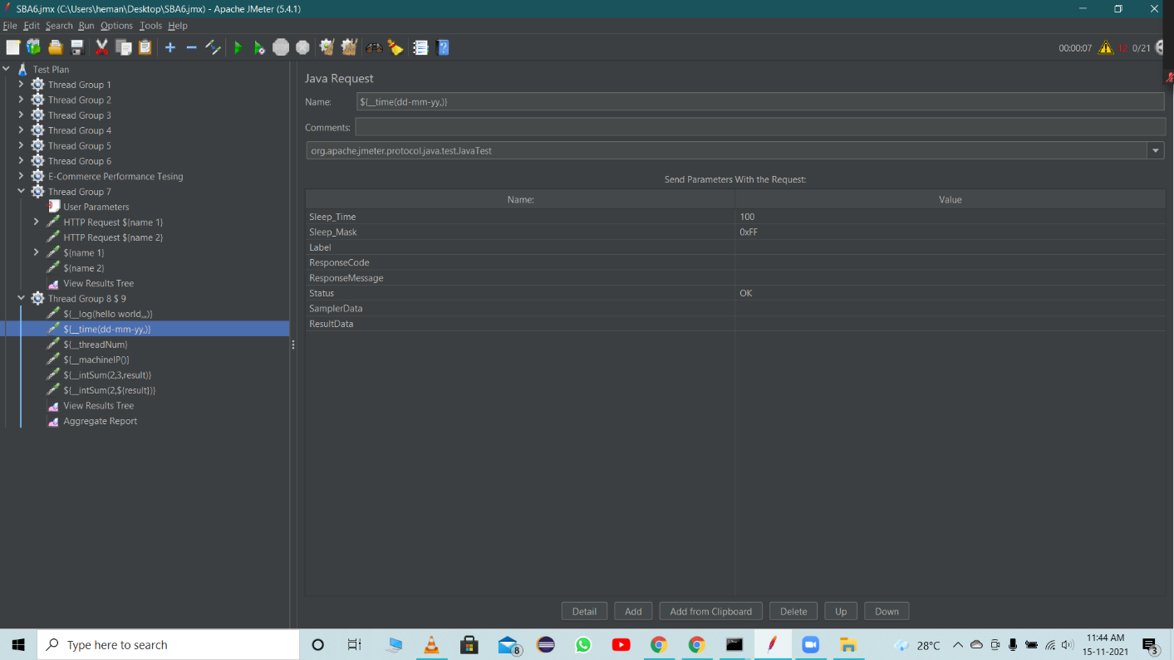

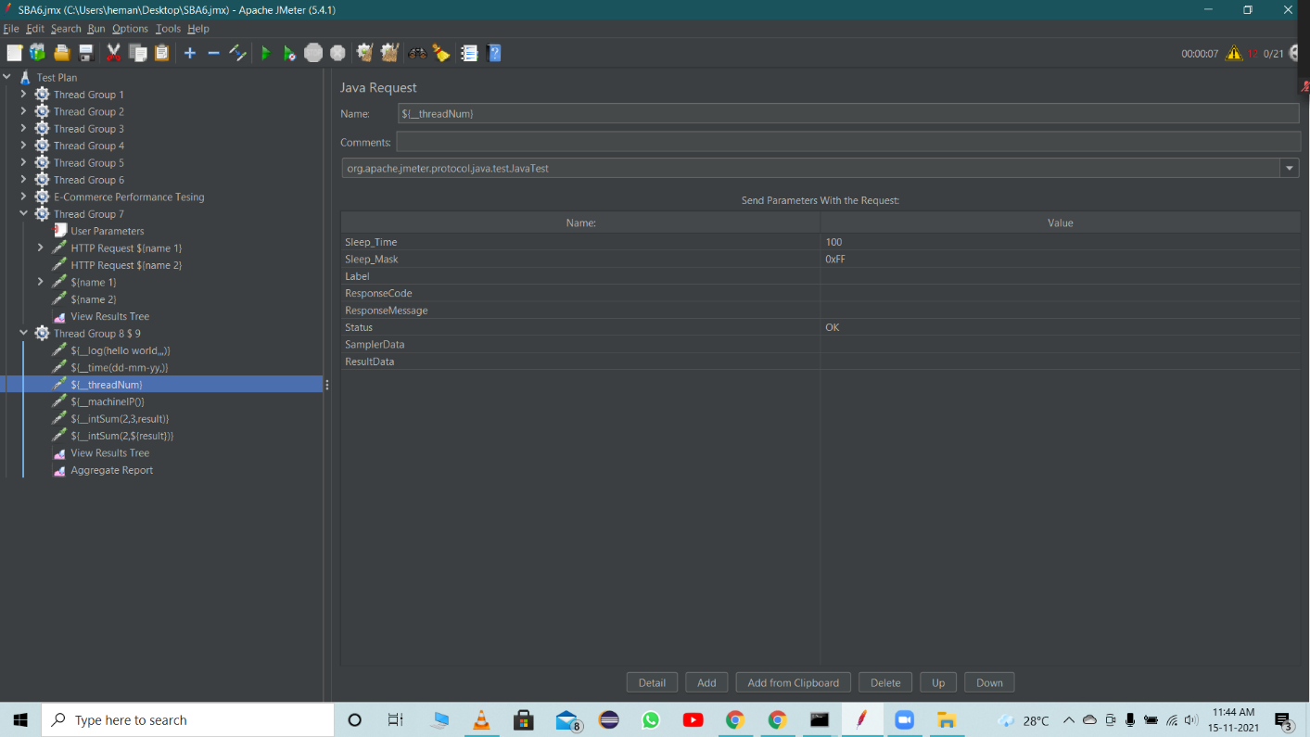

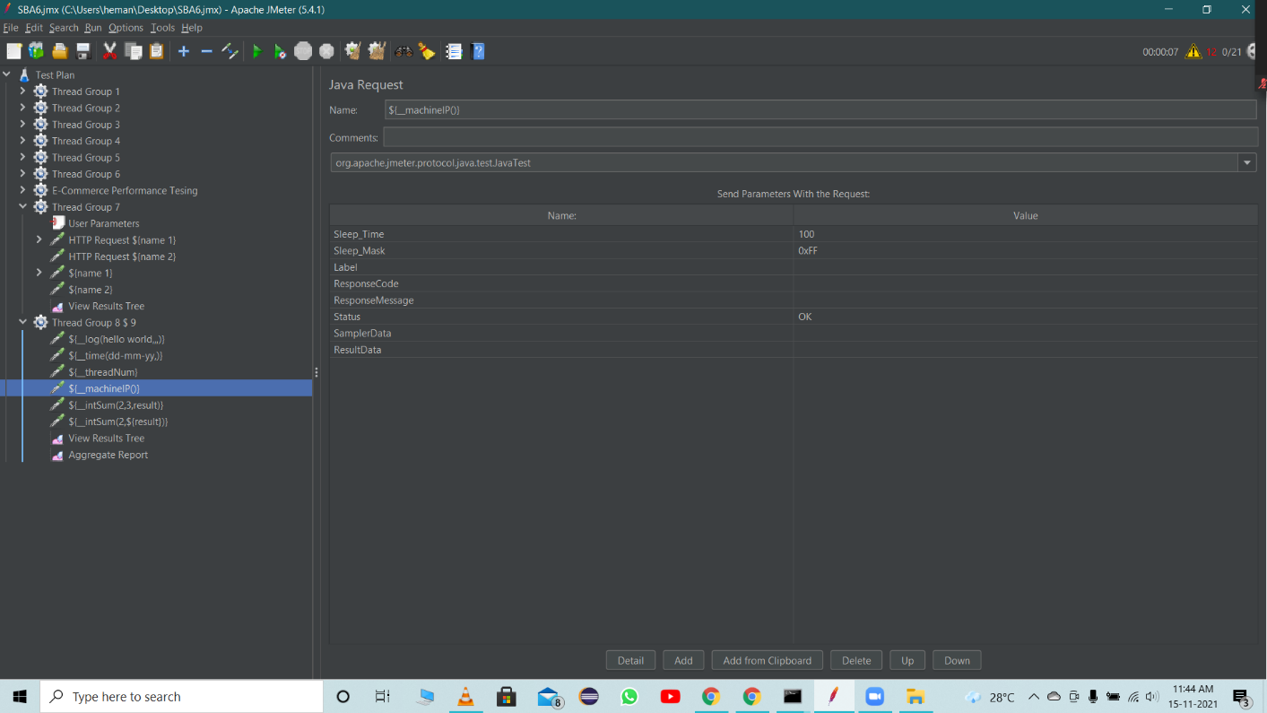

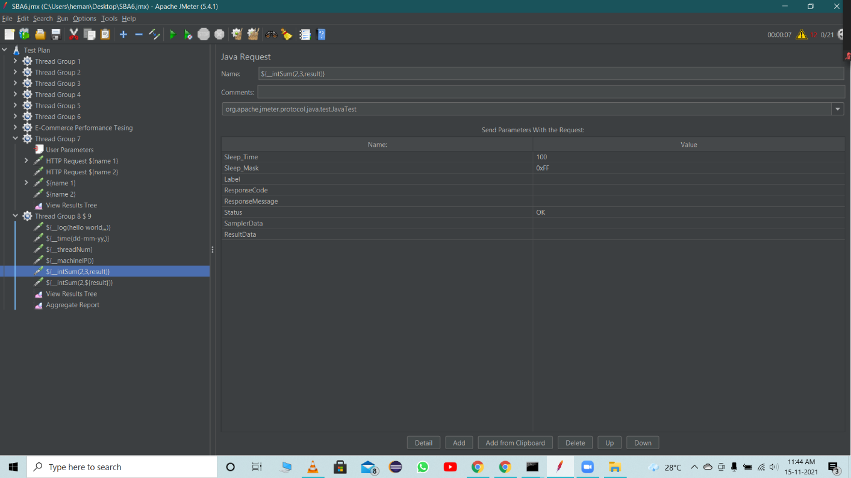

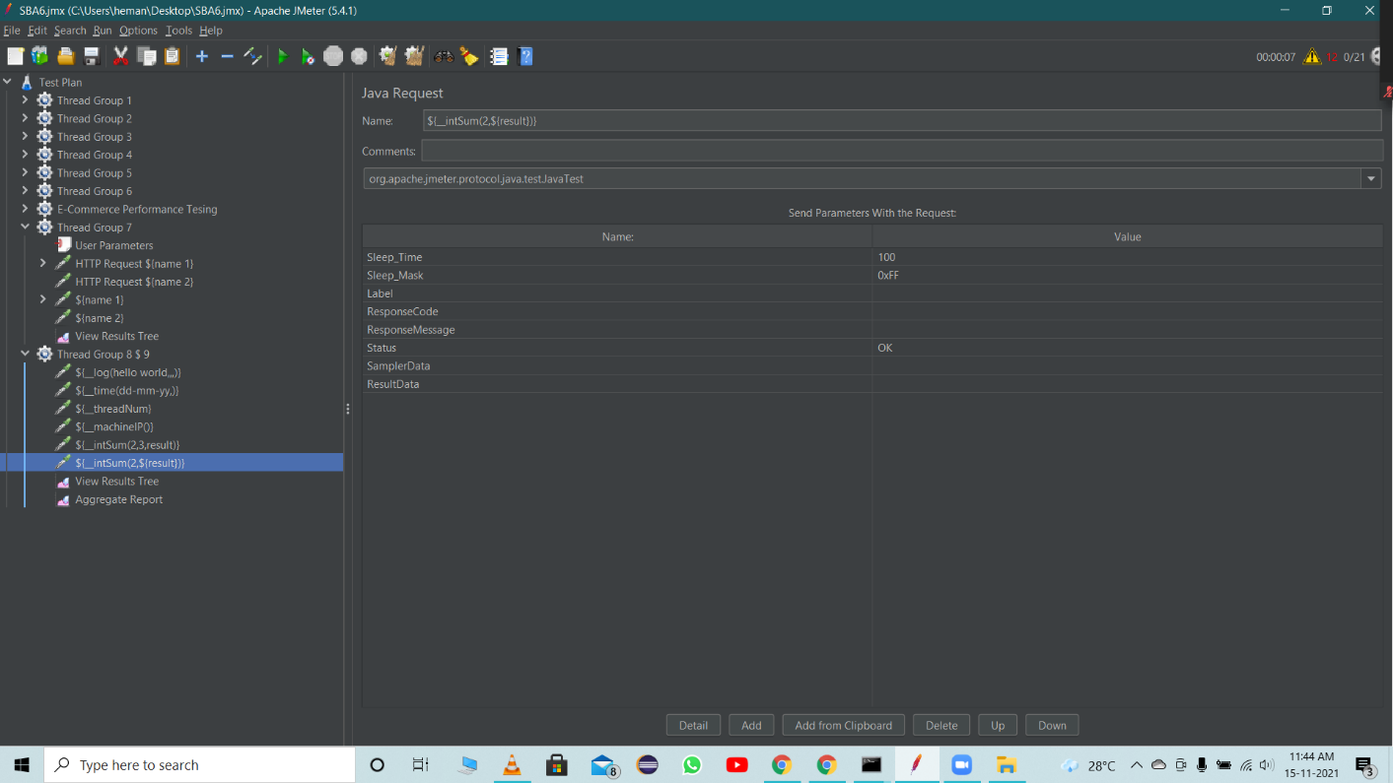

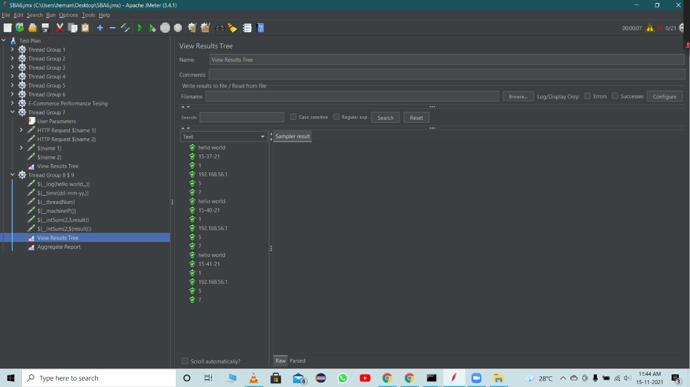

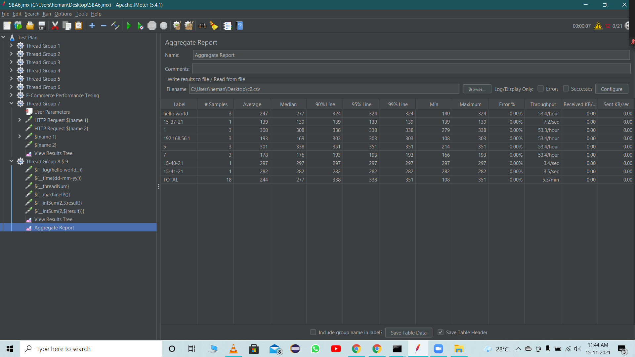

**HTML Report in JMeter**

HTML reports are very intuitive. Most of the time development team and upper management need this report to evaluate performance of a particular site or application.

Steps:

* Create a thread group
* Add some HTTP requests
* Add Listener
* Add Aggregate Reports

**Generating HTML Report**

Add output data into CSV file

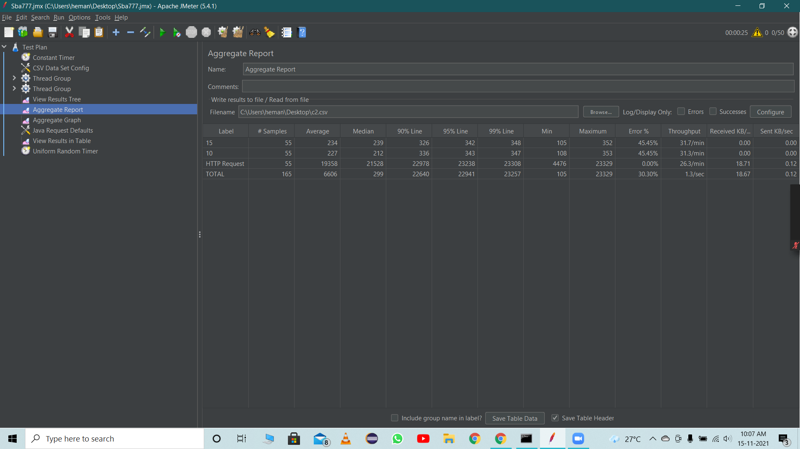

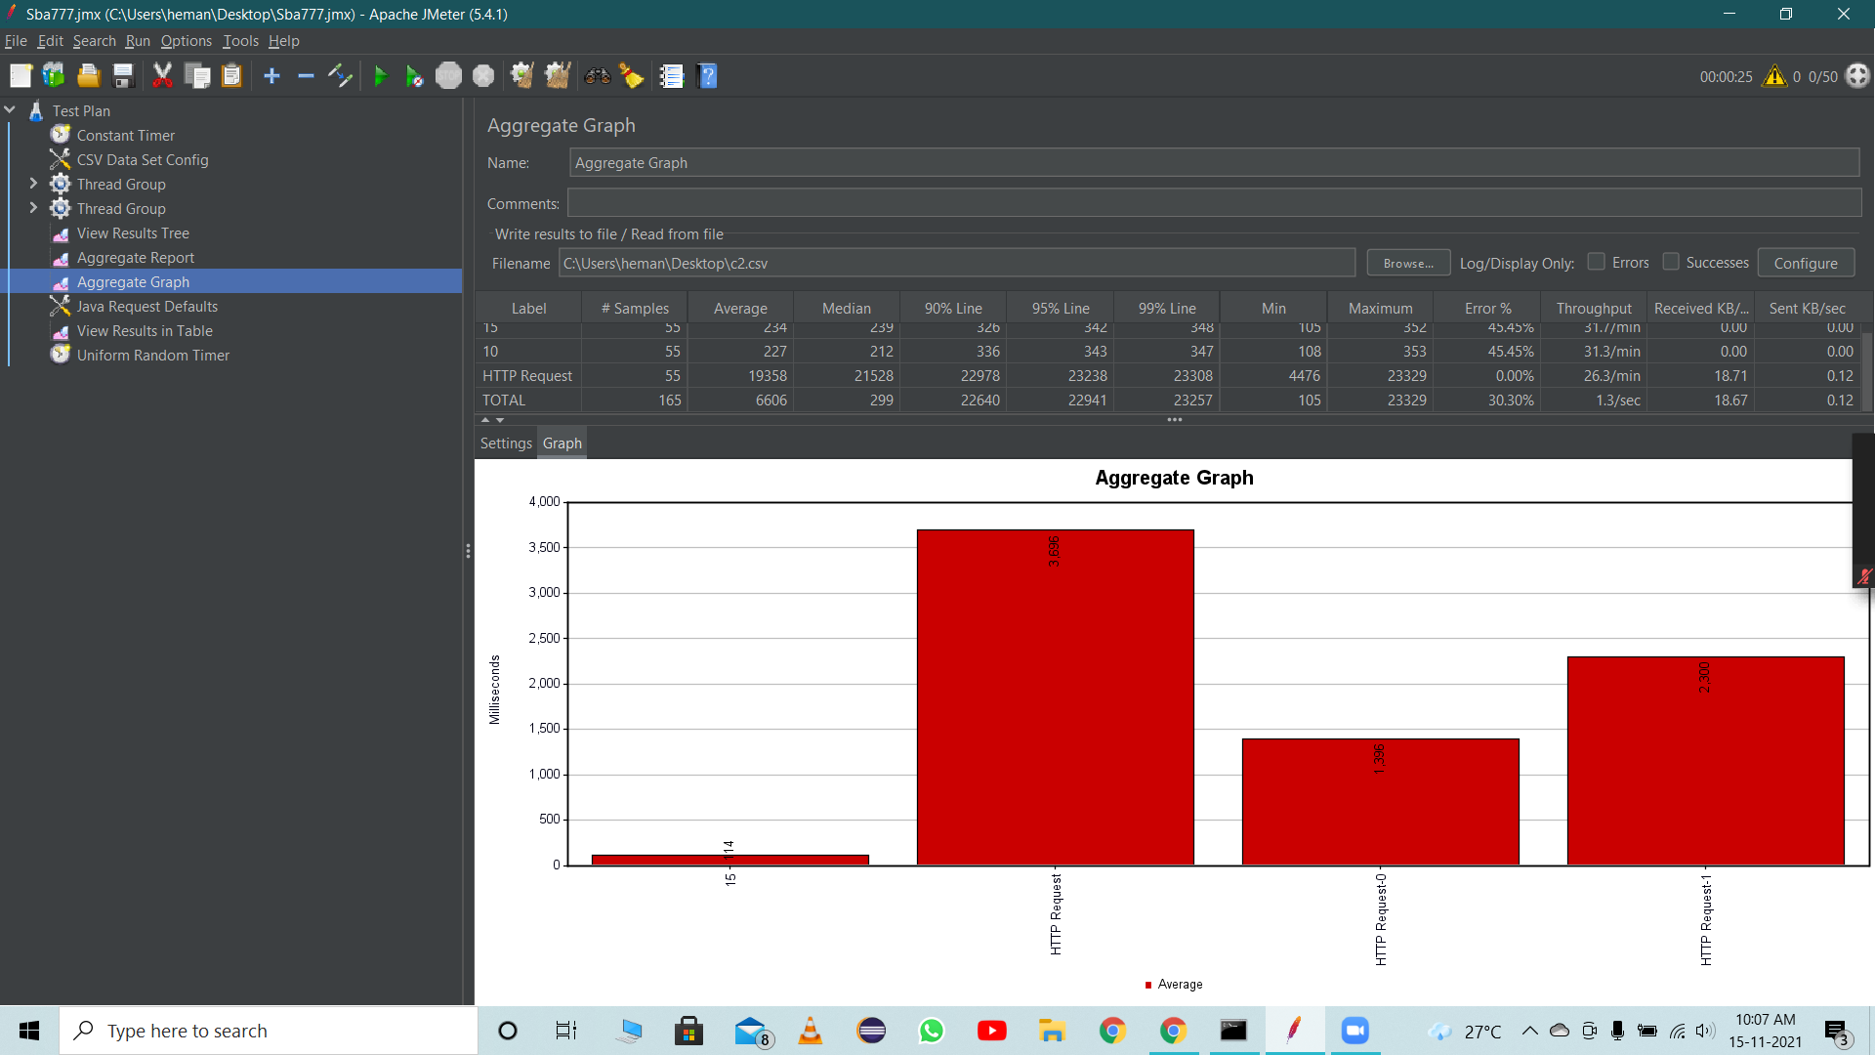

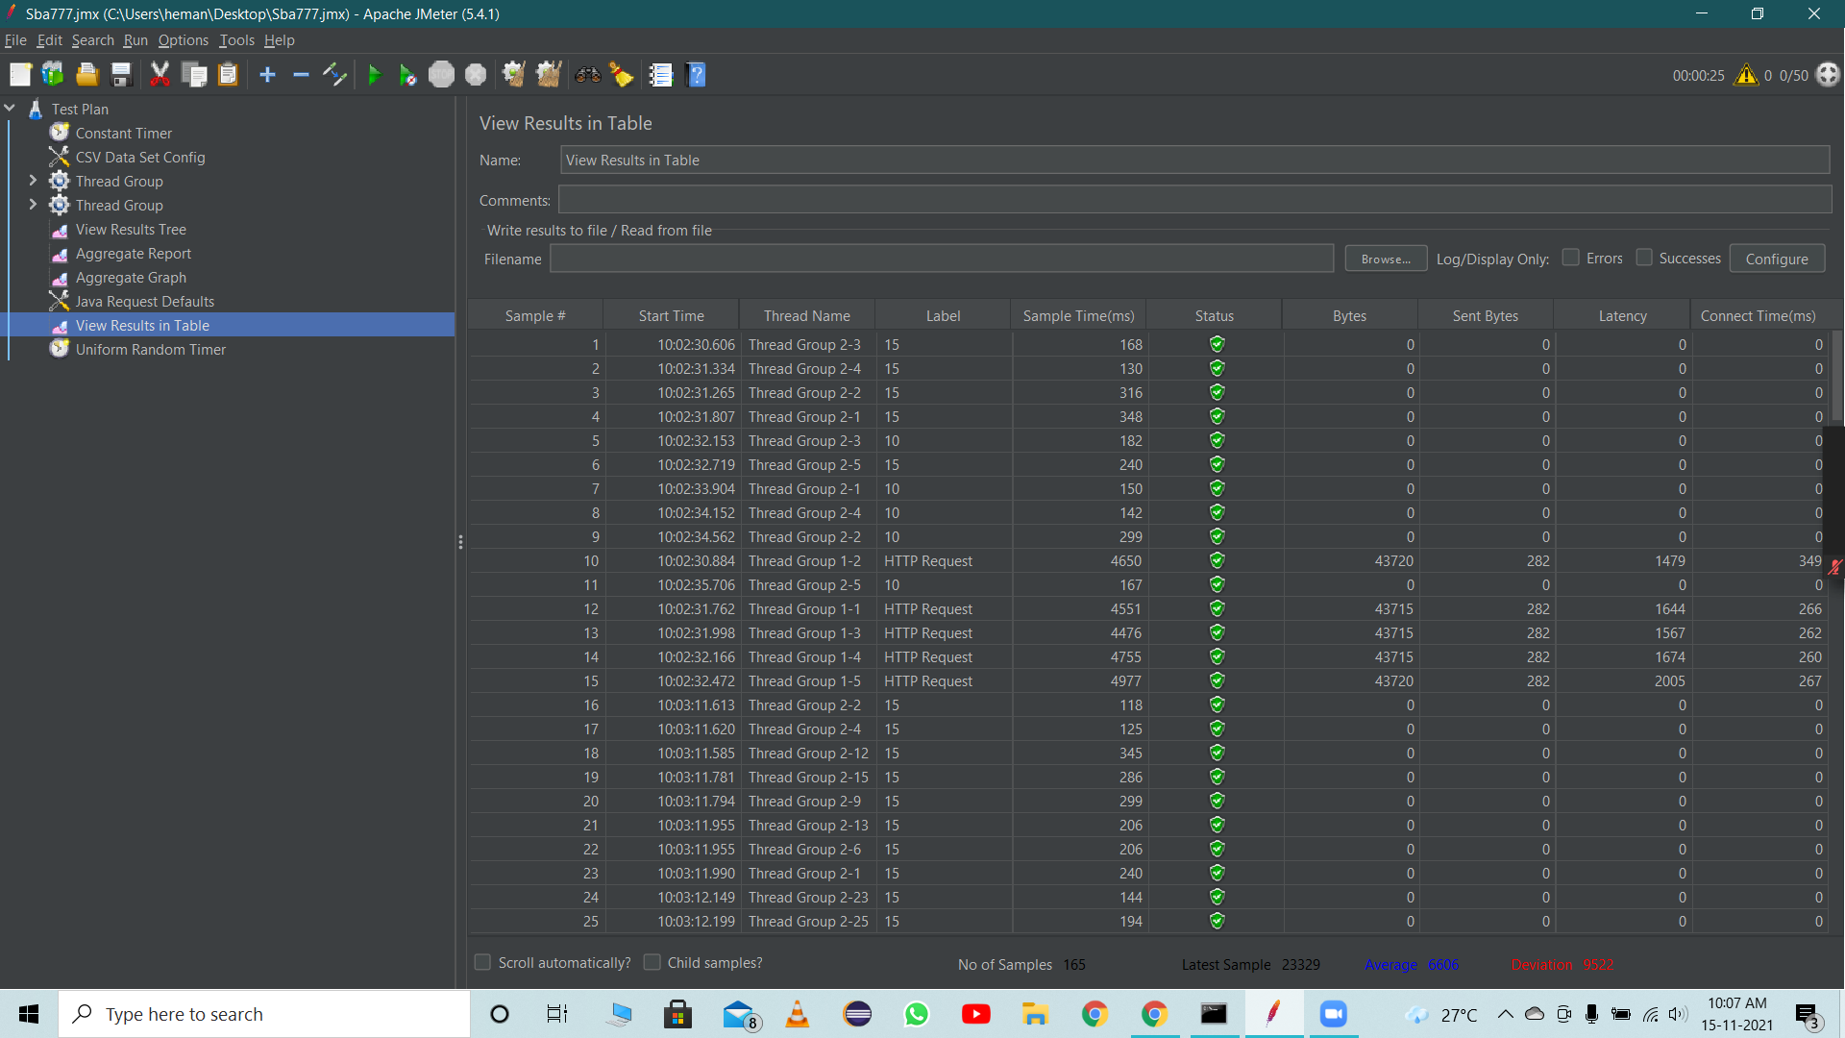

Click on tools and choose option for generating HTML report

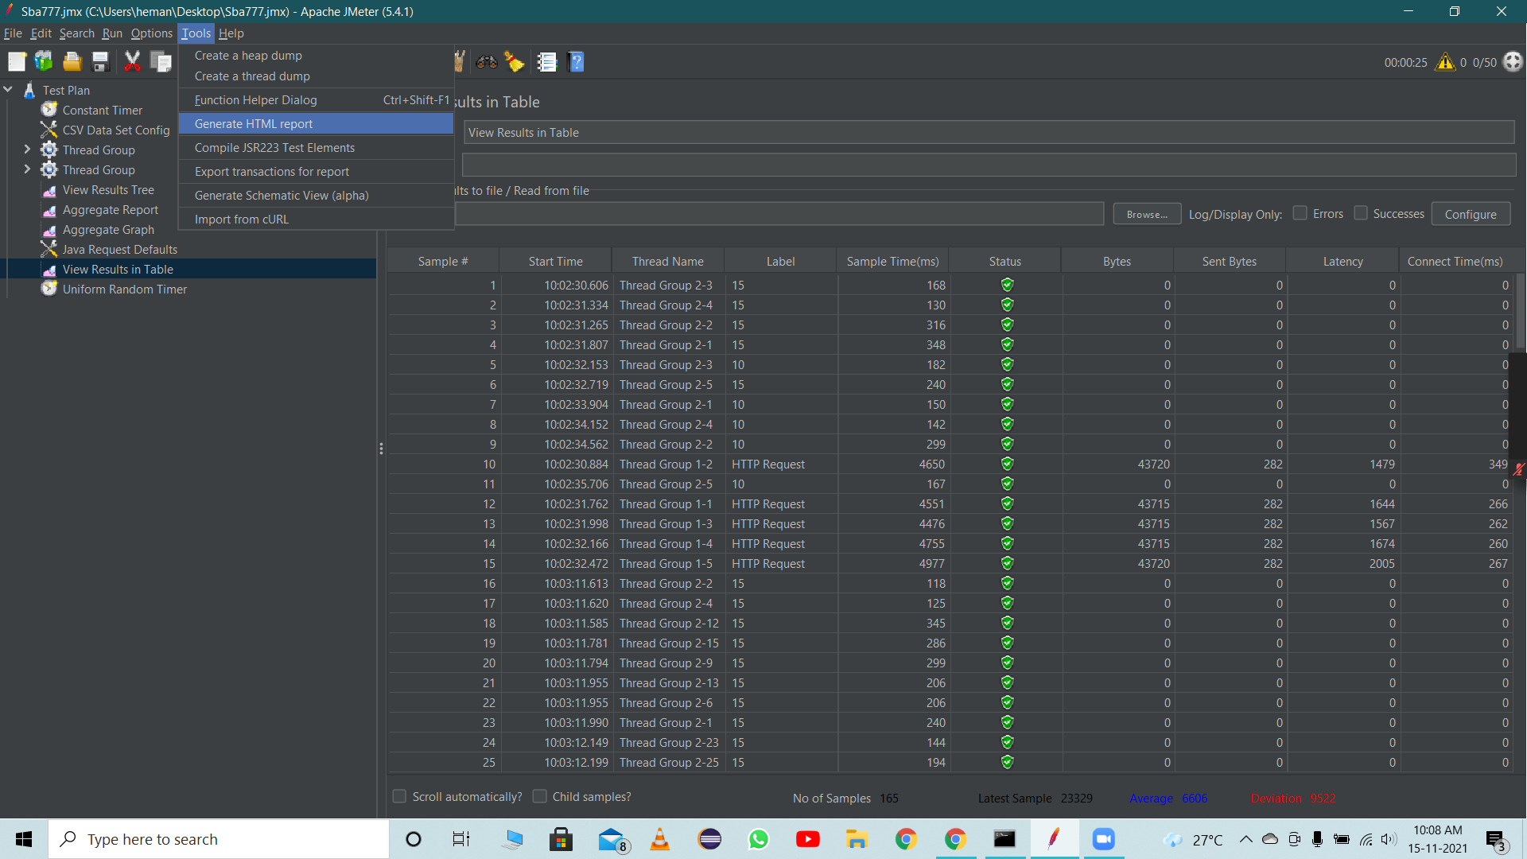

Give all the required paths

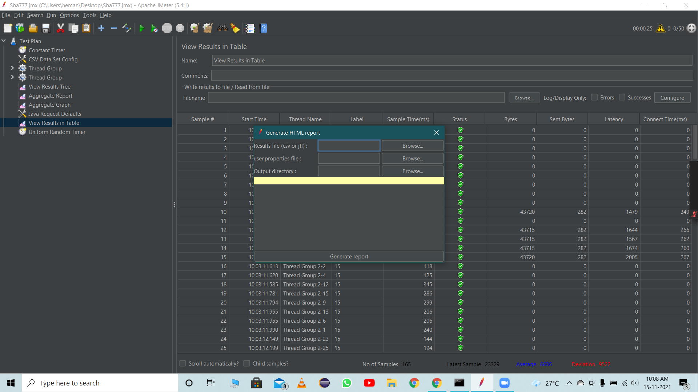

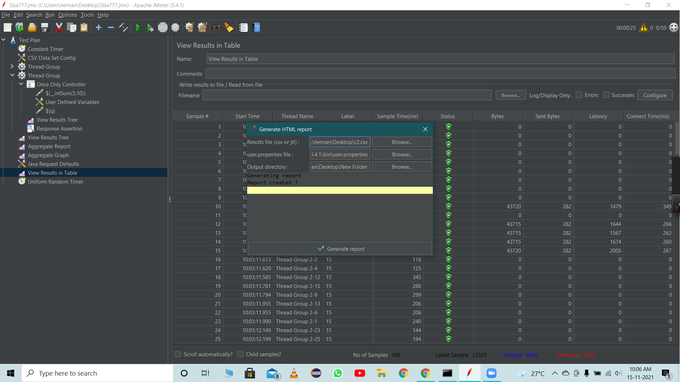

Folder created for output directory

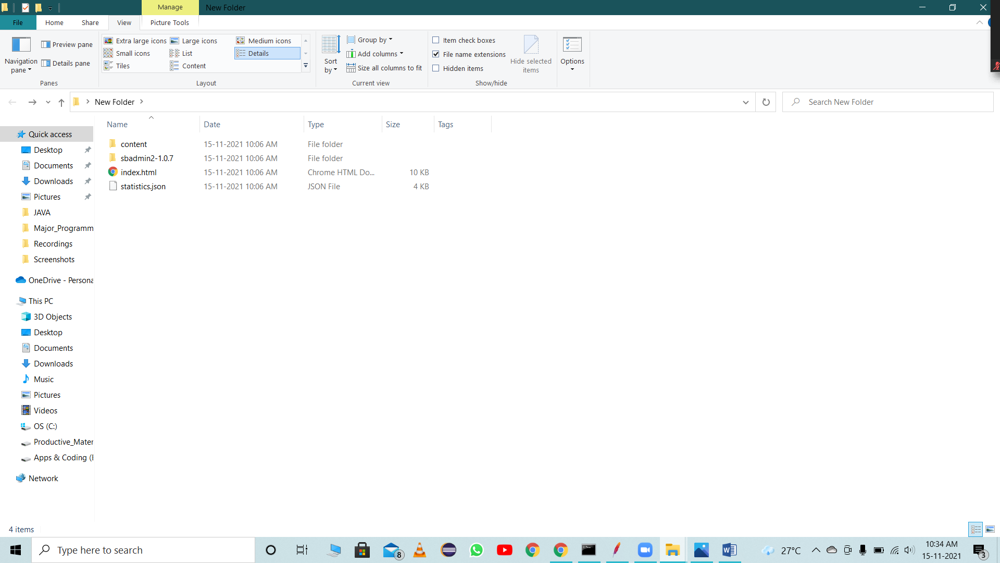

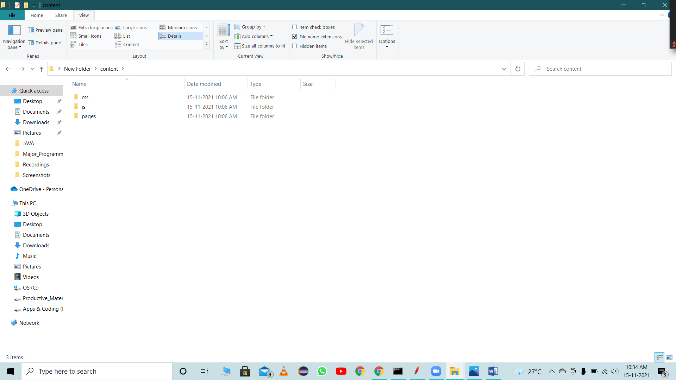

* Generated HTML report

